VINCENT by Tim BURTON
Jeremy Faisant TZR Corrèze
jeremyfaisant@hotmail.com

LEVEL B1 ( 3è- seconde)
Type of Document : Short movie
Aims : SKILLS : listening - speaking -writing -phonetics (intonation and rhymes)
LANGUAGE : Physical description
Comparatives
Expressing an opinion
Biography writing
Probability

Brainstorming autour de scary movies : WHO ?

Monsters | Animals and people
Vampire - mummy  Poltergeist - Ghost  Werewolf - Zombie  skeleton - witch  The grim reaper | Black cats  spiders  Snake  bats  rats

Scary culture

Horror stories | Horror films | Authors
Doctor Jekyll and Mister Hyde  Frankenstein  Dracula  Interview with the vampire | Scream - Evil Dead  Friday the 13th - Candyman  The Texas Chainsaw Massacre The Shining - The Exorcist  The Amityville Horror | Stephen King  HP Lovecraft  James Herbert  Dean Koontz  Ann Rice

Short movie introduction >1’ (freeze frame au moment où Vincent ouvre la porte)
Repérages globaux (Wh-questions)
Vincent Malloy a 7-year-old boy . He plays the flute and he has got / owns a black cat. He wants to/ would like to be like Vincent Price.

Repérage des noms. Passer à la description physique des deux personnages.
Voir transparent A.
Penser à fournir une wordbank. (voir Spring 3è looks + NAP 4è)
Vincent Malloy looks young. He is rather cute. He looks / doesn’t look pleased. He is wearing a striped shirt. His hair is not well combed. He is holding a black cat.
Vincent Price looks old. He’s got a moustache. He is quite ugly. He looks tired because he has dark rings under his eyes. His hair is tousled / he is shaggy-haired. He is wearing a dressing gown.
Compare them. Mise en plume : proposer comme titre Mr Malloy and Doctor Price.
(on peut aussi proposer cette activité après avoir rempli les portraits des deux personnages… dans ce cas on pensera à inclure les adjectives suivants
considerate –nice – polite – tormented)

Penser à utiliser des structures de contrastes
Unlike, contrary to
Both, the same … as
Look like + N et look + adj

Short movie: Overall comprehension

Démarche proposée

Visionnement intégral avec brouillon… What did you hear ?

Remplir la worksheet en arrêtant l’image aux endroits donnés sur la fiche prof.
Se contenter de la première partie (avant Vincent’s nightmare)

Quelle technique ? Avantages et inconvénients.

1- remplir l’intégralité de la fiche de compréhension.
Cette technique me semble assez ardue pour les élèves dans la mesure où on leur demande de regarder- écouter- lire et écrire simultanément.

2- couper la classe en deux, chaque moitié de la classe s’occupant d’un personnage. Cette démarche demande beaucoup d’énergie et une maîtrise totale de sa classe. Il faut en effet gérer l’attention des élèves, les informations sur chaque personnage étant assez rassemblées.
Elle présente tout de même un avantage intéressant bien que très lourd au niveau logistique : en coupant la classe en trois cette fois, on peut proposer un jeu de questions-réponses basé sur l’information gap.
Group 1 visionne le film et trouve les informations
Group 2 prépare des questions sur Vincent Malloy
Group 3 prépare des questions sur Vincent Price

3- Travailler avec le groupe classe en relevant d’abord les informations sur Vincent Malloy puis celles sur Vincent Price. Cette technique est la plus simple à mettre en œuvre. Elle peut néanmoins créer un sentiment de lassitude chez les élèves puis qu’elle implique deux visionnements consécutifs

Difficultés de compréhension

La compréhension n’a pas besoin d’être exhaustive. On trouvera en majuscules sur la fiche prof le minimum exigible. Pour certaines informations plus difficiles, rechercher les sons. Après plusieurs visionnements / écoutes, les élèves devraient s’être aperçus qu’il s’agit d’un poème (sinon leur montrer la strophe qui se trouve sur la worksheet)

Ex : he does what he’s told : trouver la rime avec old (il nous appartient ensuite de donner obedient).

Cours n°2

Warming up + PPC describe one character. Compare them.
More comparisons… utiliser le Transparent B. repérer les ressemblances entre Burton et Vincent et la ressemblance évidente entre les deux Vincent Price.

Vincent’s nightmare

Contourner la difficulté de “the room started to sway shiver and creek”
Sway : penser à the Twin Towers (Spring 3 lesson 6)
Shiver : évoquer une chanson de Natalie Imbruglia
Creek : exiger le [i :]

Commentary
Expression Orale : donner une wordbank : how to express an opinion
Les élèves cochent ce qu’ils veulent (pourquoi pas les 3), leur fournir le vocabulaire dont ils ont besoin.

Justify : production d’énoncés (50 mots minimum exigible en 3è)
Aide méthodologique individualisée.

Homework : recopier/ terminer au propre la production écrite

Distribuer le script du poème.
Repérage de vocabulaire par champs lexicaux autour de ‘scary vocabulary’

Adjectives | Nouns | Climate and time | places | verbs
possessed, mad, terrified, limp, lifeless | Crime, horrors, experiments, insanity, screams, tale, doom | Night, fog, shadow, rain, storm, thunder | Grave, tower, hall, door, coffin, lab(oratory) | Bury, banish, burst, sway, shiver, creak, creep

Follow up activities

Séance en salle multimédia orienter les élèves vers le site suivant www.wikipedia.com (encyclopédie gratuite sur le net)
Life lines: Edgar Allan Poe
Tim Burton
Vincent Price
Travail sur le vocabulaire : dérivation autour de LIFE and DEATH

Verb | Noun | Adjective | Adverb
Live | Life | - Alive  - lifeless  - living | lively
Die | - death  - a dead  - a living dead | - dead  - deadly | deadly

Travail sur les rimes. Faire repérer les sons aux élèves puis examiner le rapport graphie/phonie.

Ecrire une nouvelle strophe.
Ex d’amorce : Vincent woke up from a terrible dream
Faire apprendre une strophe par élève puis tenter un ‘class challenge’ en faisant réciter le poème en flux continu sans interruption.

NB : Pour faciliter ces deux activités, il est possible d’utiliser la bande son du court-métrage.

Travail sur la modalité

Il est probable que les élèves veuillent dire « I think he is strange or crazy… »
Les laisser s’exprimer et imaginer le rapport entre l’éducation de Vincent et sa personnalité. Soyons clairs, laissons les élèves s’exprimer sur leur deuxième source de contraintes après les professeurs, à savoir les parents.
Voir fiche Vincent’s personality. Travail sur les modaux should et would + PRL sur le preterit modal.
Cette fiche a déjà été utilisée en 3è sur un projet différent (seuls les noms ont été modifiés). Les élèves ont beaucoup aimé se mettre à la place d’adultes… ou plus précisément de parents.==> à distribuer en début d’heure avec un groupe faible, plus tard dans la séance pour un groupe plus à l’aise (il est cependant utile de la donner pour aider à une production écrite en homework)

Activités créées avec le logiciel Hot Potatoes.

Crosswords / matching / exercice lacunaire pour plus d’information jeremyfaisant@hotmail.com

Sitographie

ENGLISH

www.wikipedia.com
www.vincent.madonna-online.ch
http://www.awn.com/mag/issue1.9/articles/frierson1.9.html
http://membres.lycos.fr/timburton1/01vincentsynops.htm
http://www.ed-wood.net/timindex.htm
http://greylodge.org/gpc/?p=54

FRENCH

http://www.tim-burton.net/?rep_rubrique=dossiers/vincent&page_centre=index
http://films.psychovision.net/critique/vincent-213.php

Ressources

Le court-métrage Vincent est disponible sur le DVD de L’étrange Noël de Monsieur Jack
(édition spéciale) disponible sur le net (www.amazon.fr) ou en supermarché pour 9.99
Pour le trouver allez dans Bonus Material / More / Tim Burton’s Early Films/ Vincent

Pour obtenir la piste audio du court métrage aux formats MP3 ou WAV (lisible à partir de n’importe quel poste CD ou lecteur DVD), contactez-moi jeremyfaisant@hotmail.com

Remarque sur la fiche profs :

Vous trouverez en m ajuscules le minimum exigible tant au niveau de la compréhension / lecture de l’image que de l’élucidation.
En rouge les indications compteurs : où faire un freeze frame
En bleu, les informations que les élèves doivent avoir sur leur worksheet.
En vert, quelques pistes de travail.


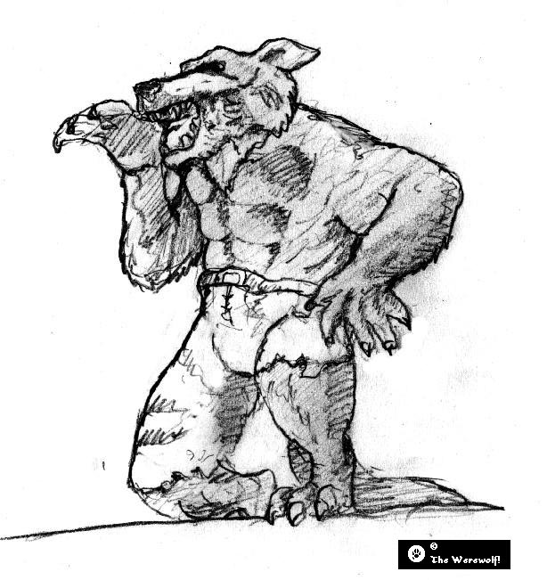
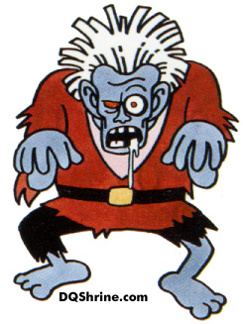


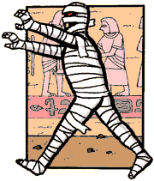
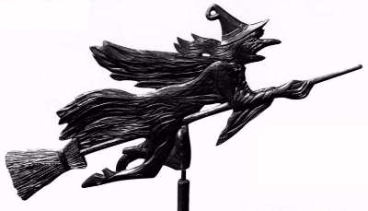








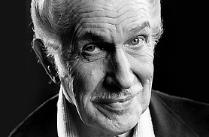


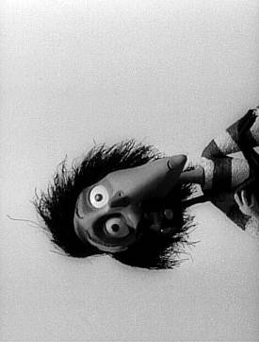

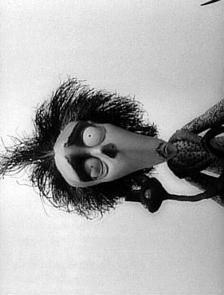


VINCENT

MEET THE TWO VINCENTS
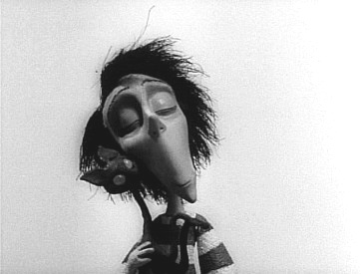

NameVINCENT MALLOY 0’35

Age SEVEN 0’36

His qualities
POLITE (0’39) he does what he is told (0’39)
considerate (0’42) NICE (0’43)

Who is his hero? VINCENT PRICE (0’46)

His family background

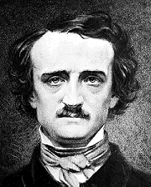
Who does he live with? SISTER DOGS CATS (1’04)

Who is his favourite author? E.Allan POE ( 2’30)

VINCENT’S NIGHTMARE

The room started to sway (4’17) shiver (4’18) and creek (4’19)

What can you hear or see? flashes and thunder (4’24) A ZOMBIE (4’25) SKELETON HANDS (4’33) screams (4’47)
THE END 4’53

What happens?____________________________________________________________________________
_________________________________________________________________________________________

Is it fiction or reality? Why? Fiction because he is dreaming, playing, pretending to be dead

About the short movie...

What do you think about it? ⁯sad ⁯scary ⁯amusing

Justify (think of the music, the colours, narrator’s voice...)
Gloomy voice, black and white, the music is very sad, it sounds…, blurred vision

Now write...Which Vincent do you prefer?

One night, while reading a gruesome tale
He read a passage that made him turn pale
Such horrible news he could not survive
For his beautiful wife had been buried alive
He dug out her grave to make sure she was dead
Unaware that her grave was his mothers flower bed

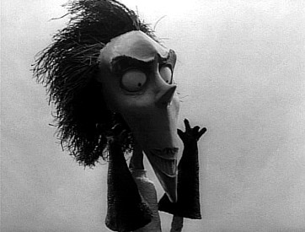
Name (ils le devinent avec l’image peut etre et le titre Two vincents) 0’50
What has changed ?
Physical description OLDER, MOUSTACHE, his hair Voir scene à 0’50
Pets SPIDERS AND BATS ( 1’09)
Personality ALONE and tormented (1’30)
Job an inventor (1’21)
His family MARRIED (2’41) voire a widower
What happened to her?
SHE DIED or she was buried alive ( 2’42)
What does he like doing?
PAINTING ( 2’22) and READING (2’30)
Who is his favourite author?
__________________________________

VINCENT directed by Tim Burton

MEET THE TWO VINCENTS

Name_______________________

Age________________________

His qualities
____________________ ____________________
____________________ ____________________

Who is his hero?______________________________

His family background

Who does he live with?_______________________

Who is his favourite author?
____________________________________

VINCENT’S NIGHTMARE

The room started to ____________________ ___________________ ___________________

What can you hear or see?______________________________________________________ ______

THE END

What happens?____________________________________________________________________________
_________________________________________________________________________________________

Is it fiction or reality? Why? _________________________________________________________________________________________

About the short movie...

What do you think about it? ⁯sad ⁯scary ⁯amusing

Justify (think of the music, the colours, narrator’s voice...)
__________________________________________________________________________________________________________________________________________________________________________________

Now write...Which Vincent do you prefer?

One night, while reading a gruesome tale
He read a passage that made him turn pale
Such horrible news he could not survive
For his beautiful wife had been buried alive
He dug out her grave to make sure she was dead
Unaware that her grave was his mothers flower bed

Name________________________
What has changed ?
Physical description
______________________________________________________________________________________
Pets________________ ___________________
Personality ____________ ____________
Job _______________________________
His family __________________________
What happened to her?
___________________________________
What does he like doing?
_________________________________
Who is his favourite author?
__________________________________

VINCENT

01  05  10  15  20  25  30 | Vincent Malloy is seven years old  He's always polite and does as he's told  For a boy his age, he's considerate and nice  But he wants to be just like Vincent Price  He doesn't mind living with his sister, dog, and cats  Though he'd rather share a home with spiders and bats  There he could reflect on the horrors he’s invented  and wander dark hallways, alone and tormented  Vincent is nice when his aunt comes to see him  But imagines dipping her in wax for his wax museum  He likes to experiment on his dog Abercrombie  In the hopes of creating a horrible zombie  So he and his horrible zombie dog  could go searching for victims in the London fog  His thoughts, though aren't only of ghoulish crimes  He likes to paint and read to pass some of the times  While other kids read books like "Go Jane Go!"  Vincent's favourite author is Edgar Allen Poe.  One night while reading a gruesome tale  he read a passage that made him turn pale  Such horrible news he could not survive  For his beautiful wife had been buried alive  He dug out her grave to make sure she was dead  Unaware that her grave was his mother's flower bed  His mother sent Vincent off to his room  He knew he'd been banished to the tower of doom  where he was sentenced to spend the rest of his life  alone with the portrait of his beautiful wife.  While alone and insane encased in his tomb  Vincent's mother burst suddenly into the room  She said, "If you want to, you can go out and play  It's sunny outside and a beautiful day." | 35  40  45  50  55 | Vincent tried to talk but he just couldn't speak  the years of isolation had made him quite weak  So he took out some paper and scrawled with a pen:  "I am possessed by this house and can never leave it again."  His mother said, "You are NOT possessed and you are NOT almost dead  These games that you play are all in your head  You are NOT Vincent Price, you're Vincent Malloy  You're not tormented or insane, you're just a young boy  You're seven years old, and you are my son  I want you to get outside and have some real fun."  Her anger now spent, she walked out through the hall  While Vincent backed slowly against the wall  The room started to sway, to shiver and creak  His horrid insanity had reached its peak  He saw Abercrombie, his zombie slave  and heard his wife call from beyond the grave  She spoke from her coffin and made ghoulish demands  While, through cracking walls, reached skeleton hands  Every horror in his life that had crept through his dreams  swept his mad laughter to terrified screams!  To escape the madness, he reached for the door  but fell limp and lifeless down on the floor  His voice was soft and very slow  As he quoted "The Raven" from Edgar Allen Poe:  "And my soul from out that shadow  That lies floating on the floor  Shall be lifted?  Nevermore…"  Written by Tim Burton.

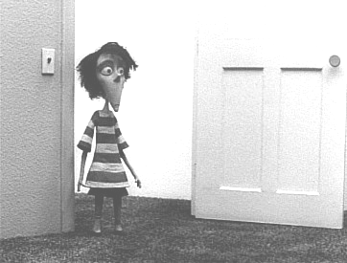
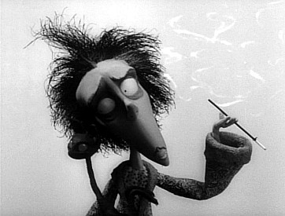
VINCENT’S PERSONALITY

Now let’s talk about Vincent…

Give as many adjectives as you can to describe him…

________________________________________________________________________________________________________________________________________________________________________________

What Vincent’s parents do ? Here are a few ideas. Put them in a chart.
Say if they should or should not do it.
+ (_________) | (_________)
Consult with a psychologist
Punish him
Keep him in his room
Let him do
Threaten him
Send him to a boarding school
Let him read horror books
Allow him to watch scary movies

Now imagine you are Vincent’s parents

If I were Vincent’s parents
If I were in their shoes , I + list
If I were in their position

Avec l’expression if I were…, I , je me mets à __________________________________. J’émets une hypothèse, mais on ne peut pas dire qu’elle soit réelle. Comme je m’écarte de la réalité présente, j’utilise le __________________ . Je suis en décalage par rapport à la réalité. Dans la 2è partie de l’expression j’utilise . Il est entre le ____________________ et le __________________ et il modifie leur relation. est donc un __________________.

