An introduction to American Civil War Poetry
1. Revision
Who was the American Civil War fought by?
___________________________________________________________________________
Who was the American Civil War won by?
___________________________________________________________________________
What was abolished in 1865, after the Civil War?
___________________________________________________________________________
2. Vocabulary
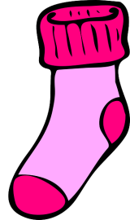
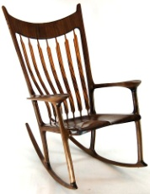
a) Match each word to an image: Rocker, Stocking, Knit, drums.
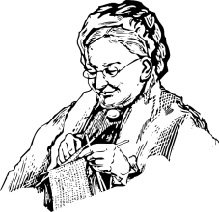

_______________ _____________________ _________________ ______________
b) Link each word to a definition:
Troop - - Adj. Made out of wool (sheep’s hair)
Woollen - - Noun. A woman who has lost her husband
Widow - - Noun. A Group of soldiers
Still - - Adv. Even now (toujours) OR Adj. Immobile
3. Read the poem and fill in the table with information about the lady:
Appearance
Activities

Family

4. Read the poem again and answer the following questions:
a) Stanza 2- When and why did the lady’s sons leave her?
___________________________________________________________________________
b) Stanza 2- What happened to her sons?
___________________________________________________________________________
c) Stanzas 3 and 4- True or False (justify your answer):
She was playing the drums when she discovered that her first son had died. ___________________
___________________________________________________________________________
Her son wrote a letter before he died. ______________________________________________
___________________________________________________________________________
The lady didn’t believe that her sons had died. ________________________________________
___________________________________________________________________________

Bonus questions
1. How does this poem make you feel?
This poem makes me feel ______________________ because ___________________________
______________________________________________________________________________________________________________________________________________________
2. Analyse the title of the poem.
____________________________________________________________________________________________________________________________________________________________________________________________________________________________________________________________________________________________________________

