Annexe 1

1.

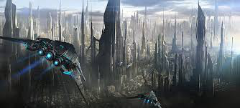

*commons.wikipedia.org*

2.

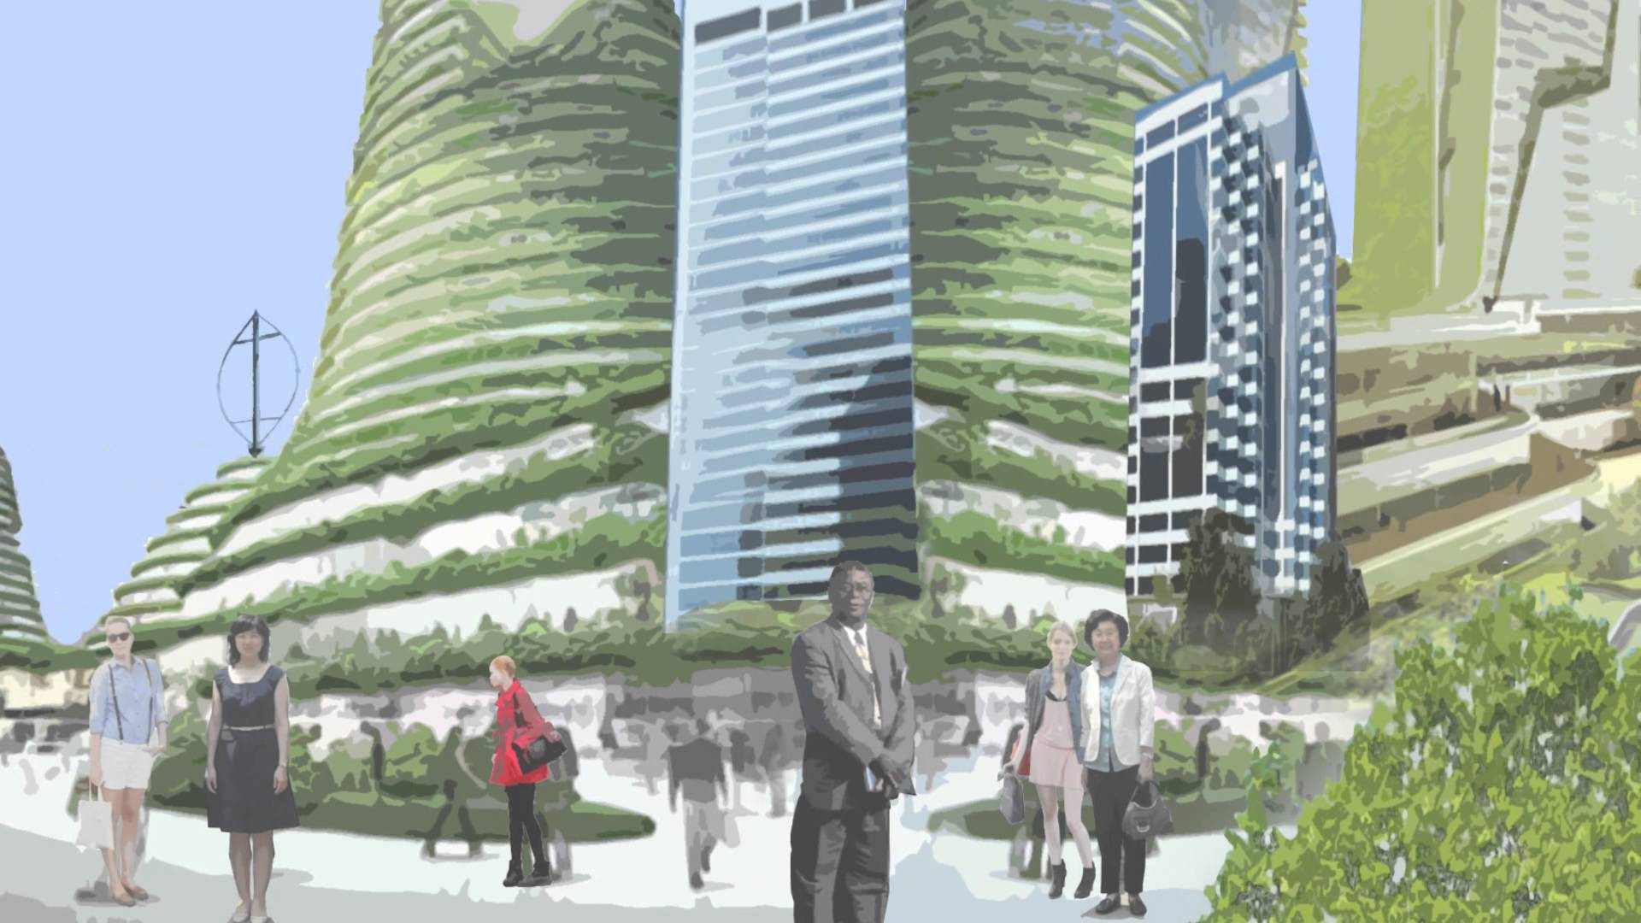

*youtube.com*