[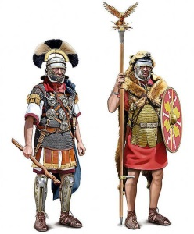](https://www.google.fr/url?sa=i&rct=j&q=&esrc=s&source=images&cd=&ved=2ahUKEwiEpZ77qI7iAhUSJBoKHXcjD2IQjRx6BAgBEAU&url=https://www.pinterest.pt/pin/548665167090197254/&psig=AOvVaw1KbszgGwQymECssMkopOlY&ust=1557486891428076)[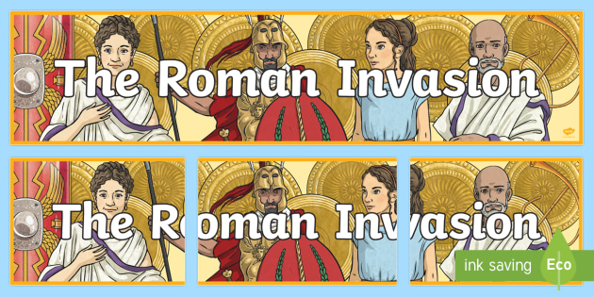](https://www.google.fr/url?sa=i&rct=j&q=&esrc=s&source=images&cd=&cad=rja&uact=8&ved=2ahUKEwj1lLXf_43iAhWx8uAKHUrADaAQjRx6BAgBEAU&url=https://www.twinkl.co.uk/resource/t2-h-201-the-roman-invasion-display-banner&psig=AOvVaw3qoWd1PyC72pc-P9_9pYZH&ust=1557475758587614)

*Roman soldiers*

After about 100 BC, the Celts in mainland Europe came under attack from German and Central European warriors. From Italy, toot, Roman armies marched northwards to conquer the Gauls.

In 55 BC the Roman general Julius Caesar landed near Deal, in Kent, with 10,000 troops.

He met with furious resistance, but returned the following year with

at least 30,000 foot soldiers and 2000 cavalry. This time they crossed

the River Thames and invaded the tribal lands of the Catuvellauni,

Belgic Celts who had settled around St Albans. After a long fight,

the British Celts promised to pay tribute to Rome so they were left

in peace.

Nearly a hundred years later, after Caesar’s death, a new invasion

took place led by the unpopular Emperor Claudius who wanted to

conquer a new land to get the support of the people of Rome.

In AD 42, he raised an army that was 40,000 strong, four legions of

soldiers and an equal number of cavalrymen crossed the Channel in

three divisions, landing on the south coast. Claudius’s intention was to bring the whole of Britain under Roman rule. The Romans wanted to invade Britain to expand their empire, to look for riches like : copper, gold, iron and tin and also to find good land for farming.

Many Celtic tribes tried to resist but the Romans troops, under general Aulus Plautius defeated them. The biggest battle was fought by the River Medway where the Romans broke throught the massed tribes. Advancing through Essex, the Romans captured Camulodunum (Colchester). It was there that the Emperor Claudius took surrender of 11 tribes.

[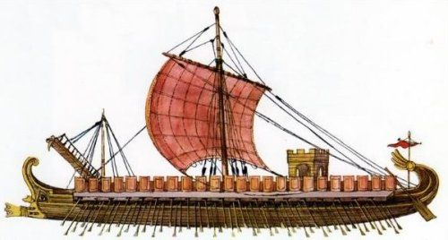](https://www.google.fr/url?sa=i&rct=j&q=&esrc=s&source=images&cd=&ved=2ahUKEwiyid_bvI7iAhWr1uAKHXXWCvUQjRx6BAgBEAU&url=https://www.pinterest.com/pin/295126581811229417/&psig=AOvVaw0A1bBEWSa-270m8jCWBiZ7&ust=1557492185637809)All in all, it took about four years for the invaders to finally gain control over southern England, and another 30 years to conquer all the West country and the mountains and the valleys of Wales.

[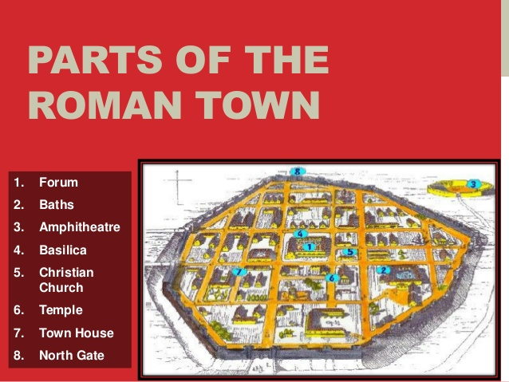](https://www.google.fr/url?sa=i&rct=j&q=&esrc=s&source=images&cd=&cad=rja&uact=8&ved=2ahUKEwi9hqS2qo7iAhUtyYUKHV5zDcUQjRx6BAgBEAU&url=https://www.slideshare.net/rociobautista/roman-urbanism&psig=AOvVaw1DT6tJZAkyXrMjUMOcNayp&ust=1557487109184306)When the Romans came to Britain they brought their way of life with them. Over time, the people of Britain and the Romans mixed. The Britons began to live the Roman lifestyle and the Romans took on local customs.

The Romans built new towns.

These were often protected by walls

and there was everything a citizen of

Roman Britain would need inside –

houses, shops, meeting spaces,

workshops, temples and bathhouses.

Every town had public baths.

The baths were a Roman institution,

and most town inhabitants went there

every day. They were open to both

sexes, though at different times of day.

[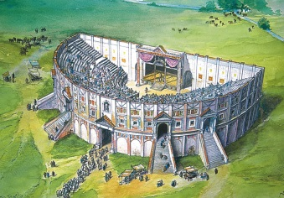](https://www.google.fr/url?sa=i&rct=j&q=&esrc=s&source=images&cd=&cad=rja&uact=8&ved=2ahUKEwj4k52Fuo7iAhXaAmMBHUGgC4wQjRx6BAgBEAU&url=https://heritagecalling.com/2015/01/06/6-sites-that-help-us-better-understand-roman-entertainment/&psig=AOvVaw112GF7hlpuCygsawlAeokN&ust=1557491432719323)Many towns also offered the entertainments of the theatre and amphitheatre. The theatre was an open air tiered clam-shell offering shows from classical plays,

pantomime to religious festivals. In the amphitheatre which

was an open air oval, people could see gladiatorial combats,

contests between men and animals, and public executions.

The Romans also introduced new foods into Britain, among them celery, cabbages, radishes, cucumbers, broad beans and walnuts. Romans cooked on charcoal stoves. Olive oil was imported. So were olives, figs and grapes. Wine was also imported (although the Romans attempted to grow vines in Britain). The Romans were also very fond of fish sauce called *liquamen*. They also liked oysters, which were exported from Britain. A Roman dining room was called a *triclinium*. The Romans ate a breakfast of bread and fruit called the *ientaculum*. At midday they ate a meal called the *prandium* of fish, cold meat, bread and vegetables. The main meal was called the *cena* and was eaten in the evening.

[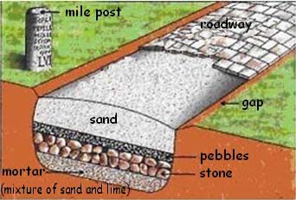](https://www.google.fr/url?sa=i&rct=j&q=&esrc=s&source=images&cd=&cad=rja&uact=8&ved=2ahUKEwi7x5XUu47iAhXqDWMBHetKBlcQjRx6BAgBEAU&url=https://www.researchgate.net/figure/Section-of-a-Roman-road-cut_fig2_259221228&psig=AOvVaw2KBqaZhlUt8CP-ESCbNyoV&ust=1557491759045886)[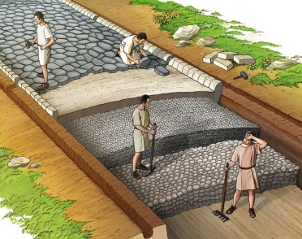](https://www.google.fr/url?sa=i&rct=j&q=&esrc=s&source=images&cd=&cad=rja&uact=8&ved=2ahUKEwiRsvG5u47iAhXC1eAKHQSUAA0QjRx6BAgBEAU&url=https://wol.jw.org/en/wol/gallery/r1/lp-e/nwtsty/E/2019/44/593&psig=AOvVaw2KBqaZhlUt8CP-ESCbNyoV&ust=1557491759045886)What the Romans were most famous for is their roads.

To make sure soldiers and supplies could move from town

to town quickly, the Romans made their roads as **straight**

as possible and connected their cities and military bases

with a network of engineered roads that stretched across

Britain. These roads, with their well-known post-Roman names

– such as Fosse Way and Ermine Street – are often still in use

as highways. The word ‘street’ (from *strata*, meaning road) is one of the few Latin words to have remained in continuous use since the Roman period.



The Romans ruled Britain for nearly 400 years from 43 AD to 410 AD. They left Britain to defend their homeland in Italy which was being threatened by barbarians such as the Goths and the Vandals but they left a lasting legacy on the culture of Britain. Roman construction such as aqueducts, roads, and concrete had a lasting impact on the people of Britain. Other aspects of Roman culture that remained in England included the Julian calendar, Roman laws and government, and many words from the Latin language. 