Name : 6....
Reading Comprehension Niveau A1→A2 du CECRL /20
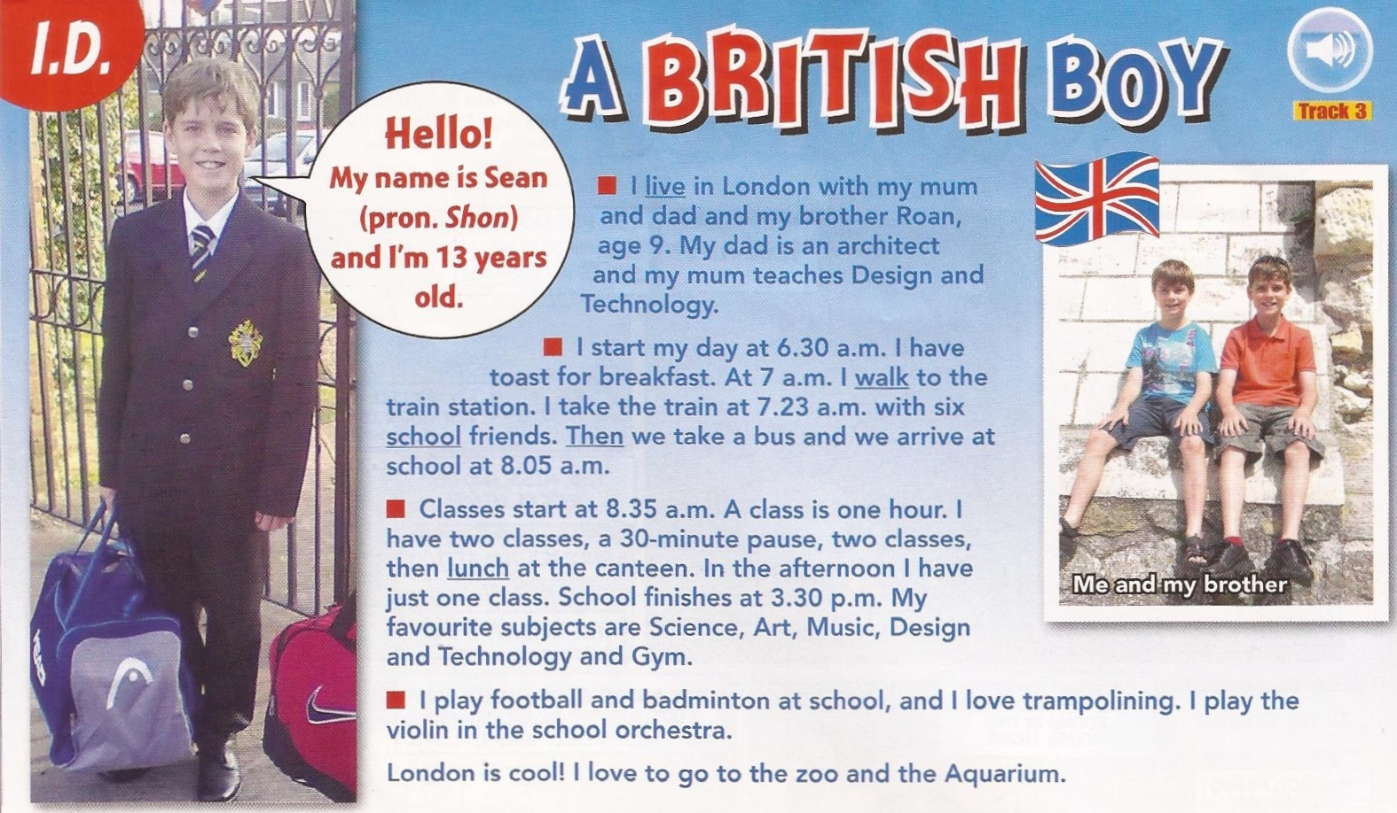 *adapted from Easy Street September 2013

Read the text and...
A/ Circle the right answer: /5
- This document is… 1pt
A text from a book - a page from a personal blog - an article from a magazine.
- This document is about… 1pt
School in Italy – an English schoolboy – Sports in England
- Look at photo 1: He must / mustn’t wear a uniform 1pt
- The boy in the photo is… Spanish – British – French 1pt
- His name is: Sean – John – Shon 1pt

B/ Answer the questions /15
- Where does he live?----------------------------------------------------------------1pt
- Has he got brothers and sisters?--------------------------------------------------1pt
- His dad is (job)----------------------------------------------------------------------1pt
- His mum is (job)---------------------------------------------------------------------1pt
- What does he eat for breakfast?-------------------------------------------------1pt
- Does he go to school…? (Circle the right answer) 2pt
walking – on a car - by bike - by bus – by train
- Does he go to school with friends? (Circle the right answer) Yes / No 1pt
- What time does he start school?--------------------------------------------------1pt
- What time does he finish school?--------------------------------------------------1pt
- Where does he eat?----------------------------------------------------------------1pt
- What subjects does he prefer?----------------------------------------------------------------------------------------------------------------------------------------------1pt
- What sports does he play? --------------------------------------------------------1pt
- What instrument does he play?---------------------------------------------------1pt
- Does he play music in the city orchestra?------------------------------------------------------------------------------------------------------------------------------------1pt

BONUS: What does Sean love doing when he is not at school? + 1pt
----------------------------------------------------------------------------------------------------------------------------------------------------------------------------------------------

