Name : 6....
Reading Comprehension Niveau A2 du CECRL /20
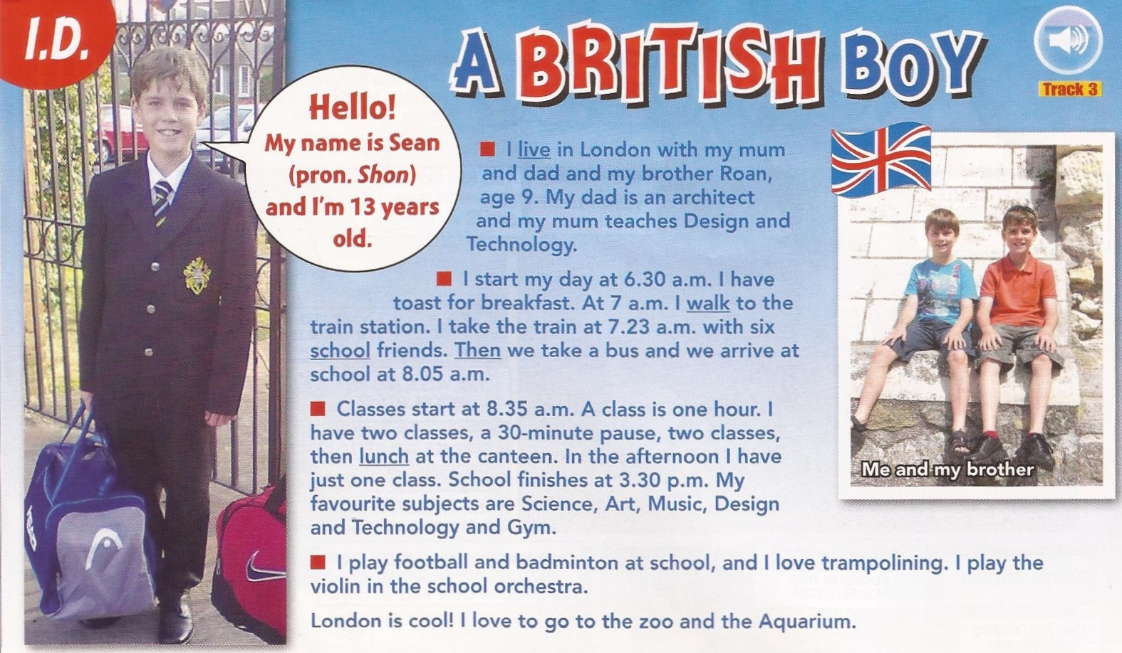 *adapted from Easy Street September 2013
Read the text and...
A/ Circle the right answer: /2
- What sort of document is this? 1pt
A text from a book - a page from a personal blog - an article from a magazine.
- This document is about… 1pt
a typical British family – a typical schoolday in the life of a British student - Hobbies after school
B/ Answer the following questions. Justify by quoting from the text: /18
- Are Sean’s parents divorced? 2pt ------------------------------------------------------------------------------------------------------------------------------------------------------------------
- Is Sean an only child? 2pt ----------------------------------------------------------------------
- What does he eat at breakfast? 1pt ----------------------------------------------------------
- Does he walk to school? 2pt ------------------------------------------------------------------------------------------------------------------------------------------------------------------------
- Does he go to school alone, or is he accompanied? 1pt -------------------------------------------------------------------------------------------------------------------------------------------
- What time does he start school? 1pt ----------------------------------------------------------
- What time does he have a break in the morning? 2pt ---------------------------------------------------------------------------------------------------------------------------------------------
- Where does he have lunch? 1pt ----------------------------------------------------------------
- Does school finish early or late? 1pt ---------------------------------------------------------------------------------------------------------------------------------------------------------------
- What are his favourite subjects? 1pt -------------------------------------------------------------------------------------------------------------------------------------------------------------
- Is Sean sporty? 1pt ----------------------------------------------------------------------------
- Is he musical or artistic? 1pt ---------------------------------------------------------------------------------------------------------------------------------------------------------------------
- What else does he like doing in his free time? 1pt ----------------------------------------------------------------------------------------------------------------------------------------------
- On the first photo where Sean is in a uniform, you can read ‘I.D’. Can you say what the initials mean? I.D = 1 pt-----------------------------------------------------------------------

Bonus: Why do you think he likes Design and Technology? + 1pt
----------------------------------------------------------------------------------------------------------------------------------------------------------------------------------------------------------------

