Name : 6....
Reading Comprehension Niveau A1 du CECRL

/20
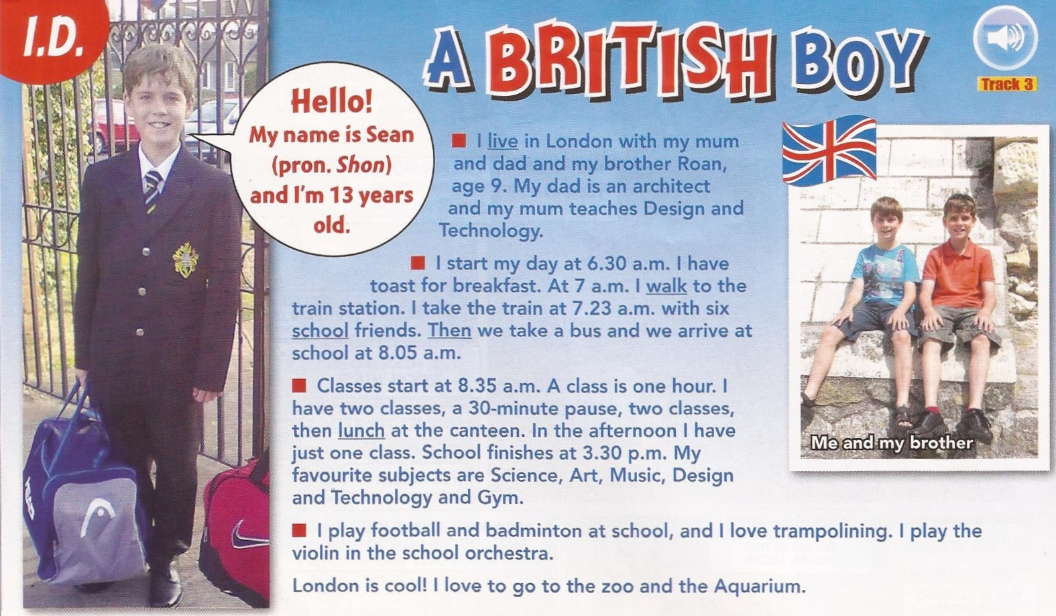 *adapted from Easy Street September 2013
Read the text and...

A/ Underline the right answer /5
- This document is… 1pt
a text from a book - a page from a personal blog – an article from a magazine
- The boy in the photo is going to… 1pt
the stadium - school – take the train – the restaurant
- He is an English boy – a French boy – an Italian boy 1pt
- His name is John – Shon - Sean 0.5pt
- He is fourteen years old – thirteen years old – eleven years old 1pt
- He lives in Ireland – in Spain – in England 0.5pt

B/ Circle the right answer: /15
- Sean lives in Bristol - in London – in Dublin 1pt
- His dad is a doctor - a teacher – an architect 1pt
- His mother is a dentist – a karate champion - a teacher - an architect 1 pt
- He has got a brother – two sisters – a pet 1pt
- He has cereals – coffee – toast for breakfast 0.5pt
- He arrives at school at 6.30 am – 7.23 am – 8.05 am 1pt
- He starts school at 8.05 am – 8.35 am – 9.00 am 1pt
- In the morning, he has …
a ten minutes pause – a fifteen minutes pause – a thirty minutes pause 2pt
- He finishes school at two o’clock - half past three - 5 o’clock 2pt
- Sean loves Maths – Art - French – Science - History & Geography – Gym 1.5pt
- He likes playing video games – rugby – football – table tennis – badminton 1pt
12- He plays the the 1pt
13- He loves - hates London 1pt

Bonus: Right or Wrong? (Circle the right answer) +1pt
- He loves animals. Right / Wrong

