SAXON SWORDS

The early Middle Ages were troubled times in Western Europe. Historians used to call this period the « Dark Ages », because it seems that the light of Roman civilisation had put out forever. The name was never really fair , for the period also saw beautiful arts and crafts, great poetry and scholarship in the new monastries. Nevertheless this was often a violent age. Invasions by Slavs and Huns in eastern and central Europe were pushing the Germanic peoples ever westwards, where they carved out new kingdoms for themselves in the ruins of the Roman Empire.

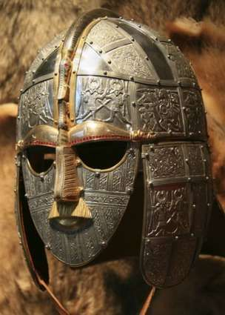
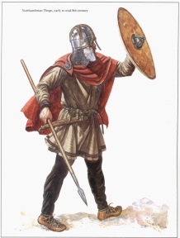
Ango-Saxon warriors of the AD 400s and 500s might be armed with a battle axe, a long sword, a spear and a long knife called sax. They wore woolen tunics, over trousers and carried round shields. Chieftains wore helmets and shirts of mail.

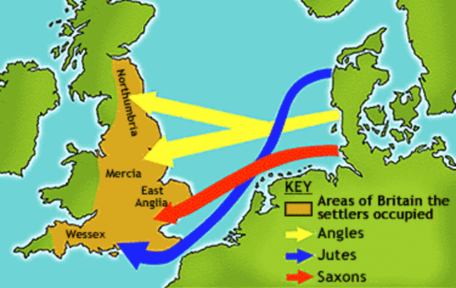
Germanic Invasions

The invaders came from the lands now occupied by Germany, Denmark and the Netherlands. They crossed the North Sea and English Channel in wooden boats and fought their way westwards.

BRITAIN AND SAXONS
The Anglo-Saxons invaders killed and enslaved many native Britons. Some fled westwards into Wales and Cornwall, or escaped to lands across the Channel that the Britons had already settled , a region known as Brittany. The Britons believed that the Angles and Saxons were savages. These peoples had never experienced Roman civilisation, nor were they Christians. In reality the two peoples shared similar European origins. They both live in small kingdoms and depended on farming and fishing. They used similar techonology and both were fine craftworkers.

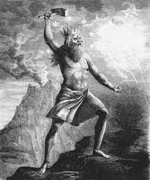
THE DAY OF WODEN
The newcomers brought with them worship of the ancient Germanic gods. These survive in English names for days of the week. For example, Wednesday is the day of Woden, the chief god. Thursday is the day of Thor, god of thunder.

ANGLO-SAXON LANDS
Modern names for countries and regions of England recall the first advances of the Anglo-Saxons. Essex comes from East Seaxe, land of the East Saxons. By AD 550 the Anglo-Saxons controlled large areas of easter and southern Britain. The Britons still ruled in the west and much of the North.

