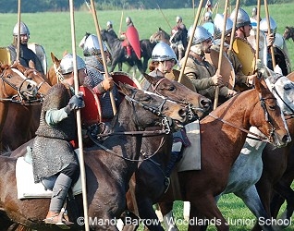

The Normans

Who were the Normans?
The Normans were people who lived in Normandy in Northern France.
They were originally Vikings from Scandinavia. (The name Normandy comes
from the French normand, meaning Norsemen and Normans)

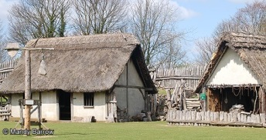
How did they live?
The Normans lived in wattle and daub huts with thatched straw roofs.
(After invading Britain they also built castles - to defend their new kingdom)
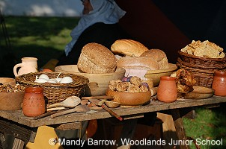
They ate what food they could grow or pick.
Vegetables e.g. leeks, onions, turnips, parsnips and carrots.
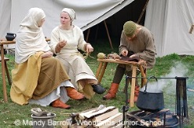
Wild nuts e.g. hazelnuts and walnuts.
Berries e.g. gooseberries, blackberries and blueberries.
Grains to make bread and also porridge
Herbs e.g. fennel, common sorrel, wild garlic, parsley
Leaves e.g. nettles and spinach
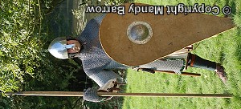
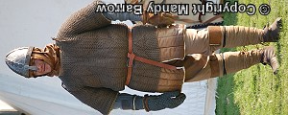
They were also good hunters and fishermen which enabled them to have meat and fish to complete their diet.
Their clothes were made of the leather they got from animals.

When and why did they invade England?
King Edward lll of England (called "The Confessor" because he built
Westminster Abbey) died on January 5, 1066, after a reign of 23 years.
Leaving no heirs, Edward's passing ignited a three-way rivalry for the crown
that culminated in the Battle of Hastings and the destruction of the Anglo-Saxon rule of England.
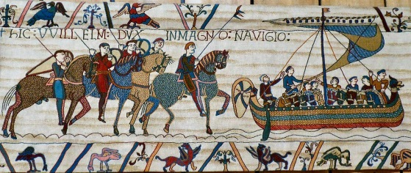
When William won the Battle of Hastings, he earned himself the title 'Conqueror'. He marched to London and was crowned King in Westminster Abbey on Christmas Day 1066.
The Battle of Hastings changed the course of History.
It made England a closer part of Europe, and for the
next three hundred years, the rulers and the nobility of
England spoke French, not English. The story of this battle
is told on the Bayeux Tapestry which is a cartoon-type picture story.

Having conquered England, William wanted to make sure he remained in control of it.
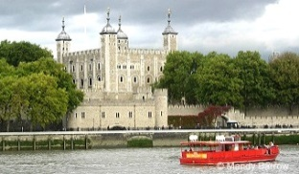
After winning the Battle of Hastings, William set about building a string
of castles in strategic areas across the country. Two of his best known
being the Tower of London (originally of wood for speed of erection) and
Windsor Castle.

Originally the castles the Normans built were wooden towers on earthen 'mottes' (mounds) with a bailey (defensive area) surrounded by earth ramparts, but many were later rebuilt in stone. By the end of William's reign over 80 castles had been built throughout his kingdom, as a permanent reminder of the new Norman feudal order.

Having conquered England, William wanted to know just how much it was worth.
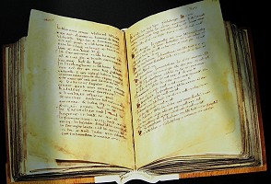
In 1086 he ordered a detailed description to be made.
In the words of the Anglo-Saxon Chronicle, ' so very
thoroughly did he have the enquiry carried out that not
even one ox or one cow or one pig escaped notice.'
All this information was written down in the Domesday Book.
The Domesday Book was, in effect, the first national census
thanks to which we know much about England in the XIth century.
Adapted from www.primaryhomeworkhelp.co.uk

