The Tudor Tatler
a
29 Jan 1547
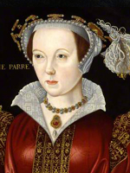
Catherine Parr was born around 1512. She was Henry VIII’s sixth and final wife. Catherine had already been married to a man called Lord Borough. She was in her teens and he was in his sixties when they married. Lord Borough soon died but Catherine soon re-married to a man called Lord Latimer. He was a frequent visitor to the royal court and Henry soon took note of Lady Latimer – Catherine.
Latimer died in 1543 and Catherine was widowed for the second time. Henry quickly began courting Catherine. She had fallen in love with a man called Thomas Seymour (Jane Seymour’s brother) but Catherine was not in a position to refuse the attentions of Henry. They were married on July 12th 1543.
Henry was now 52 years of age. Catherine was about 31. She acted as a nurse to the King. Catherine read to him while he was confined to bed, which was frequently.
Catherine was a very good step-mother to all three of his children and she was instrumental in reconciling the relationship between Henry and Mary, his first child.
She was an educated woman who loved to learn new things. Her interest in Protestantism made her enemies in court - enemies who tried to turn the king against her and have her arrested. On one occasion, the arguing went too far and Henry ordered her arrest. Luckily for Catherine, she managed to convince Henry that she was loyal to him and his religion, and was spared execution.
Henry died on January 28th 1547. Catherine was now free to marry Thomas Seymour which she did in the same year. Catherine died in September 1548 from complications that arose as a result of childbirth.
Adapted from http://www.historylearningsite.co.uk and http://www.ngkids.co.uk

NAME ___________________________________
Henry’s______________________wife.

Her love life… Find her lovers’ names and how old she was when she married them
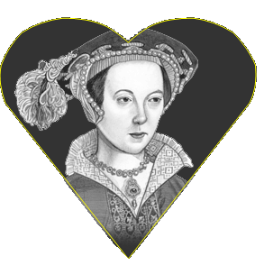
-______________________________________________
-______________________________________________
+ -______________________________________________
-______________________________________________

Read the text carefully and select the correct answer. Justify by quoting from the text
1 - Henry and Catherine always agreed  true  false
Justify___________________________________________________________________________
2 - Catherine and Mary were good friends  true  false
Justify___________________________________________________________________________
3 - Henry spent a lot of time in bed  true  false
Justify___________________________________________________________________________
4 - Catherine was popular in court  true  false
Justify___________________________________________________________________________
5 - Catherine was imprisoned  true  false
Justify___________________________________________________________________________

Finally she  divorced  was beheaded  survived
(justify___________________________________________________________________________)

Guess the meaning of the words in bold in the text. How did you find? (you can explain in French)
She was widowed____________________________________________________________________
__________________________________________________________________________________
She was spared______________________________________________________________________
_______________________________________________________________________________

The Tudor Tatler
b
20 May. 1536
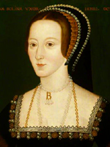
Anne Boleyn is dead. Only four months after the King buried his first wife, he has just said good bye to his second.
Anne Boleyn was not everyone’s favourite queen. Some said that it was a scandal that Henry ever married her, others went further and claimed that she was secretly a witch.
A secret wedding
Henry was hoping for a quick divorce so he would have Young Anne in his arms, but it took seven years before Anne got her wedding day. Even then we can reveal, the service was held in secret because Henry’s divorce hadn’t come through. For a short while our noble King was married to two different wives.
Boy trouble.
Witch or not witch, Anne’s spell over Henry didn’t last long. Within three years he was tired of her. All the court doctors and stargazers had predicted her baby would be a boy. The names had been chosen, Henry or Edward. But when the child came it was a girl –Elisabeth.
Anne tried again but she lost the baby. Henry, meanwhile, lost his patience. He accused Anne of having other boyfriends. One of them was court dancer, Mark Smeaton. Smeaton was arrested and soon confessed.
From that hour, no magic could save Anne. She was accused of treason which meant Henry wanted the death penalty. She was taken by boat to the Tower of London. Early on the 19 May Anne was executed. She knelt down at the block, she was blindfolded and was swiftly beheaded.
Adapted from Henry VIII and His Wicked Wives by Alan MacDonald

NAME____________________________________________
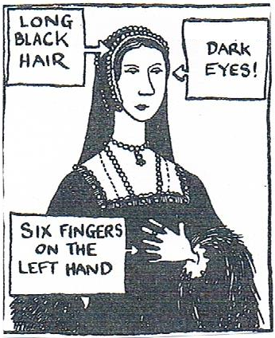
Henry’s______________________ wife
(number)

Children + name(s): ________________________________

People loved her  yes  no
Justify_________________________________________________
Married for_______________
(time )

Top secret information :__________________________________________________

Problem________________________________________________________
Accusations : __________________________ __________________________________

Sentence: _______________________________________________________________
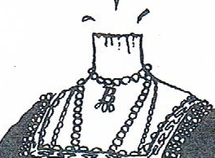
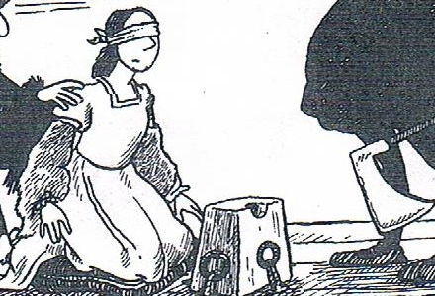
Find the corresponding verbs in the text

The Tudor Tatler
c
8 Jan. 1536
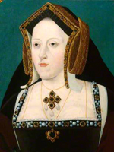
Catherine of Aragon died yesterday amid sensational rumours that she was poisoned by the King. Others claim the murder was the dirty work of Ann Boleyn, the new queen.
For 20 years Catherine was a good wife to the King
She was only 16 when she came to England. She suffered the shock of losing her first husband (Henry’s big brother, Arthur) after only five months.
Catherine may not have been a great beauty, but we English loved her. We loved her red hair and tiny doll-like hands. We loved her because she was clever, talented and fearless.
Catherine tried to be a good mother
Henry wanted a son to make sure he kept the throne in the family. And no one can say that Catherine didn’t try. She gave birth 6 times. It was not her fault that only one child –Mary- lived more than a few weeks.
The divorce was a fix
When Henry got the hots for sizzling Ann Boleyn he wanted an excuse to divorce Catherine. And what did he come up with? He suddenly decided it was wrong to have married his brother’s wife -20 years after the wedding! The marriage was annulled by the Archbishop of Canterbury. She was sent to Kimbolton castle where she lived as poor as a nun.
Adapted from Henry VIII and His Wicked Wives by Alan MacDonald

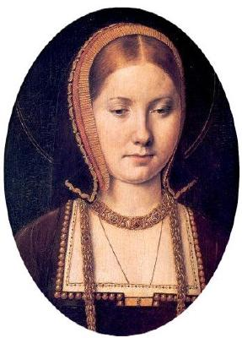
NAME___________________________________
She was Henry’s  1st  2nd  3rd  4th  5th  6th queen

First husband___________________________

Number of children (+ names)_______________________________
Married for _________________
(time)

Her qualities…she had/she was…
Physical | personality
-  - | -  -  -
Circle one word to express how people describe her in England:
popular – dangerous – rejected

Find two reasons why the marriage with Henry ended:
-________________________________________________________________________________
-________________________________________________________________________________

Decision _________________________________________________________________________

What happened next: ______________________________________________________________

The Tudor Tatler
d
25 Oct. 1537
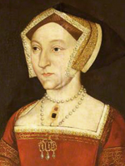
Queen Jane Seymour died shortly before midnight last night. Poor Jane lasted only 18 months on the throne. King Henry is said to be heartbroken. Only 12 days ago he was the happiest man alive. At last he had a royal son. It had taken Henry 30 years of marriage and three wives to achieve his dream. But last night it all went wrong. The King looked pale and drawn this morning as he spoke of his grief. Where Anne Boleyn was wild and bewitching, Plain Jane was sweet and sensible.
Nevertheless, Jane didn’t hang back when she saw her chance to become Queen. Only 24 hours after Anne’s head rolled off the block, Jane was secretly engaged to the King. The marriage took place just ten days later in the Queen’s room.
Boy, oh joy!
Then, on 12 Oct 1537, Jane achieved what Catherine and Anne never could. She gave birth to a healthy baby boy, Edward. Bonfires were lit around the country, 2000 cannons fired from the Tower of London and the bells rang out in every church. Only 12 days later, the same churches were draped in funeral black. Jane was buried in the chapel of Windsor.
Adapted from Henry VIII and His Wicked Wives by Alan MacDonald

NAME___________________________________
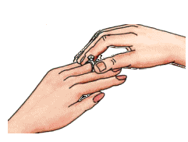
She was Henry’s  1st  2nd  3rd  4th  5th  6th queen

They got engaged_____________________________
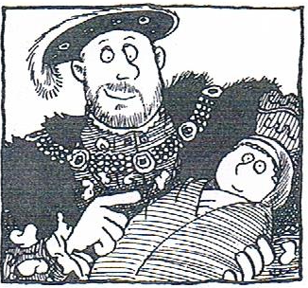

She was queen for _______________________
(time)

What happened on…
 | 12 October 1537 | 24 October 1537
Event
Celebration
Henry’s feeling

Fill in the timeline. Use the information you have already found and read the text again

27/05/1537
12/10/1537
24/10/1537

The Tudor Tatler
e
13 Feb 1542
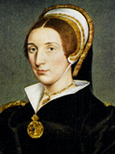
Young Catherine Howard knelt at the block today. Catherine, just 21 years old, had led a busy life. Catherine attracted men like greenfly to a rose. Here is the list of the Queen’s ex-boyfriends:
Henry Mannox : he was Catherine’s music teacher : he liked to reward his pupil with kisses.
Francis Derenham : Francis and Catherine went as far as getting secretly engaged
Thomas Culpepper : he was a knight and a member of the King’s privy Chamber.
Henry VIII : Henry was still married to his fourth wife, Anne of Cleves, when he saw Catherine. Three weeks after his divorce, Henry married his young bride. For a short while they were happy. But soon there were rumours about Catherine’s relationships with her ex-boyfriends. One by one they were arrested. Francis Derenham was dragged to the Tower and tortured. Culpeper followed soon after.
Trembling, Kate confessed she deserved a thousand deaths for offending the king. Then she knelt at the block…and was beheaded!
Adapted from Henry VIII and His Wicked Wives by Alan MacDonald

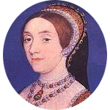
NAME : ______________________________________________________
She married at_________________________________________________
(age)

She was Henry’s  1st (first)  2nd (second)  3rd (third)
 4th (fourth)  5th (fifth)  6th (sixth) queen
Problem:
Henry was  jealous  not happy  in danger because of______________________________

Fill in the chart
Names |  | What happened
 | was Catherine’s fiancé | He was_______________________
 | was fond of instruments
 | worked with King Henry

Finally she  divorced  was beheaded  died
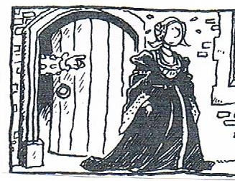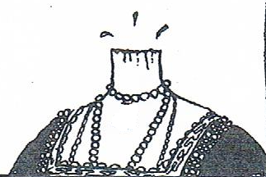

The Tudor Tatler
f
9 July 1540
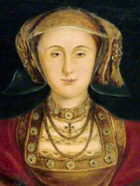
The King was persuaded to marry 23-year-old Anne of Cleves after seeing her portrait. But now Henry claims the marriage should never have got under starter’s orders. The reason? He thinks his bride is as ugly as a horse!
The marriage was doomed from the start. After 6 months it’s no great surprise that Henry’s gone roving again. This time, it’s little Catherine Howard who has caught his eye. As for Anne, she’s been shipped out to Richmond and informed Henry wants a divorce. Anne’s response to the divorce is ‘that she is content always with his Majesty’. It may be the wisest thing she’s ever said. Goodbye wife number four!
Adapted from Henry VIII and His Wicked Wives by Alan MacDonald

NAME___________________________________
She was Henry’s  1st (first)  2nd (second)  3rd (third)
 4th (fourth)  5th (fifth)  6th (sixth) queen
Age_______________________________________
Problem
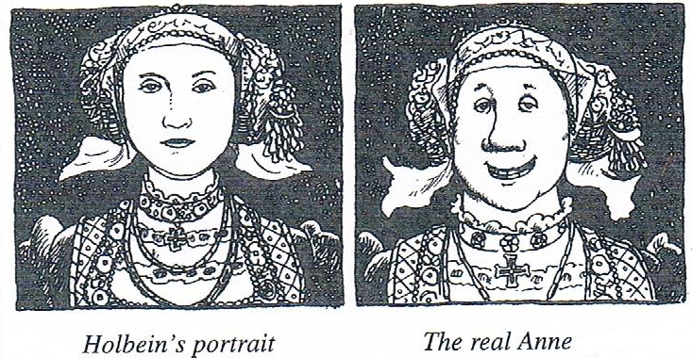
Find a sentence in the text that defines the picture above
________________________________________________________________________________

The marriage lasted__________________(time)

Henry ____________ in love with______________________
(fall)

He decided to____________________________
Justify_____________________________________________________________________________________________________________
Anne  accepted the King’s decision
 refused the King’s decision

Henry’s feeling when the marriage ended :
He __________  sad  excited  relieved  heartbroken
(feel)

Finally, Anne of Cleves  divorced  was beheaded  died

