First Mission: Listen and select the right word:
- Three | Free
- Killed | Skilled
- Bruise | Cruise
- Cost | Coast
- 400 | 4.000
- Crew | True  TEAM 1
- Later | Water
- Ireland | Island
- Passengers | Characters
- Rescue | Excuse
- To swim | To win
- Reports | Airports
- Evacuated | Evaluated
- Examination | Investigation

Second Mission :
Answer the following questions in French:
- De quel type d’évènement s’agit-il ?
- Quel est le nom du bateau ?
- Où les faits se sont-ils passés ?
- Quelles sont les nationalités des personnes impliquées ?
- Quel est le nombre de victimes ?
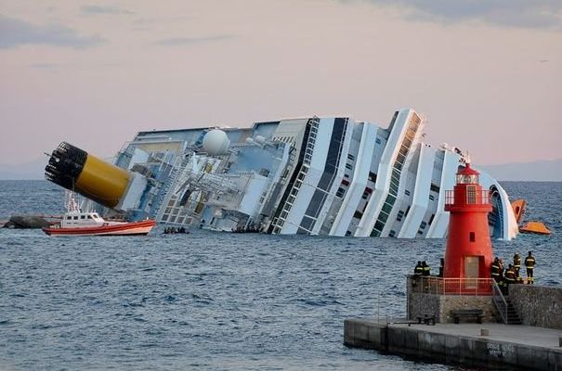

TEAM 2
First Mission: Re-order the following sentences and find the odd one out:
Les passagers étaient en train de dîner.
C’était une croisière luxueuse en Méditerranée.
Certains passagers se sont jetés à l’eau.
Le capitaine a fait preuve d’un grand courage.
Le bateau transportait 4.000 passagers.
Une enquête est en cours.
Le navire a heurté un rocher ou un banc de sable.
Les passagers étaient de nationalités différentes.
Tout le monde a été dirigé vers l’île puis le continent.
Certains passagers sont encore portés disparus.

Second Mission:
Answer the following questions in English:
- What is the document about?
- What is the name of the ship?
- Where did the scene take place?
- What were the nationalities of the passengers?
- How many people died in the wreckage?
TEAM 3
Mission One: Re-order the following sentences and find the odd one out:
The passengers were having dinner.
It was a luxury cruise on the Mediterranean sea.
Some people jumped into the water.
The captain was very courageous.
4,000 people were on board the ship.
The police is investigating.
A rock or a sand bar were hit by the ship.
The passengers came from different countries.
Everybody was taken from the island to the continent.
Some of the passengers are still missing.

Second Mission:
Answer the following questions in French:
- De quel type d’évènement s’agit-il ?
- Quel est le nom du bateau ?
- Où les faits se sont-ils passés ?
- Quelles sont les nationalités des personnes impliquées ?
- Quel est le nombre de victimes ?

TEAM 4
Listen to the video and underline the fourteen mistakes in the following script:
At least free people have been skilled and others may still be missing after a luxury
Mediterranean bruise turned to catastrophe off the cost of Italy.
The costa Concordia carrying more than 400 passengers and crew got into difficulty before
apparently hitting a rock or a sand bar.
It took on later with reports of a large gash on its side and started tipping over near the
Ireland of Gigilo while characters were eating dinner.
As the excuse operations began some on board jumped into the water to try to win ashore.
Most of those on the cruise were Italian but there were also large numbers of German and
French passengers as well as some British nationals.
First airports put the number of dead at up to eight.
Passengers and crew were evaluated to the island before being taken to the mainland.
An examination has begun into exactly what went wrong.
From Euronews Report on Costa Concordia shipwreck, January the 14th, 2012.
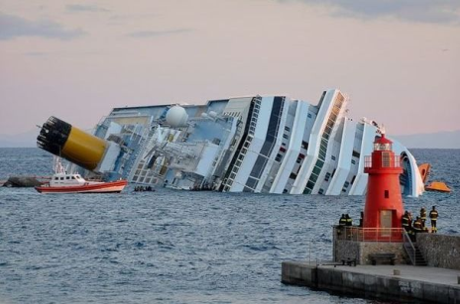
Mission 2: Now correct the wrong words.
TEAM 5
Mission One: Take notes in English; try to identify the people, the places, the events, the different parts of the story and the reasons of this shipwreck (naufrage).
Be smart! Use all the information you can see on the video.
………………………………………………………………………………………………………………………………………………..
………………………………………………………………………………………………………………………………………………..
………………………………………………………………………………………………………………………………………………..
………………………………………………………………………………………………………………………………………………..
………………………………………………………………………………………………………………………………………………..
………………………………………………………………………………………………………………………………………………..
………………………………………………………………………………………………………………………………………………..
………………………………………………………………………………………………………………………………………………..
………………………………………………………………………………………………………………………………………………..
………………………………………………………………………………………………………………………………………………..
………………………………………………………………………………………………………………………………………………..
………………………………………………………………………………………………………………………………………………..
………………………………………………………………………………………………………………………………………………..
………………………………………………………………………………………………………………………………………………..

Mission 2: Compare your notes with your partners.
Mission 3: Write a final account of the story in English on the team document.

TEAM 6
Mission One: Take notes in French; try to identify the people, the places, the events, the different parts of the story and the reasons of this shipwreck (naufrage).
Be smart! Use all the information you can see on the video.
………………………………………………………………………………………………………………………………………………..
………………………………………………………………………………………………………………………………………………..
………………………………………………………………………………………………………………………………………………..
………………………………………………………………………………………………………………………………………………..
………………………………………………………………………………………………………………………………………………..
………………………………………………………………………………………………………………………………………………..
………………………………………………………………………………………………………………………………………………..
………………………………………………………………………………………………………………………………………………..
………………………………………………………………………………………………………………………………………………..
………………………………………………………………………………………………………………………………………………..
………………………………………………………………………………………………………………………………………………..
………………………………………………………………………………………………………………………………………………..
………………………………………………………………………………………………………………………………………………..
………………………………………………………………………………………………………………………………………………..

Mission 2: Compare your notes with your partners.
Mission 3: Write a final account of the story in French on the team document.

Mission 3 TEAM WORKSHEET TEAMS: 5 and 6
Name of the team partners: …………………………………………………………………………………………………………………………………………….
Final accounts:
………………………………………………………………………………………………………………………………………………..
………………………………………………………………………………………………………………………………………………..
………………………………………………………………………………………………………………………………………………..
………………………………………………………………………………………………………………………………………………..
………………………………………………………………………………………………………………………………………………..
………………………………………………………………………………………………………………………………………………..
………………………………………………………………………………………………………………………………………………..
………………………………………………………………………………………………………………………………………………..
………………………………………………………………………………………………………………………………………………..
………………………………………………………………………………………………………………………………………………..
………………………………………………………………………………………………………………………………………………..
………………………………………………………………………………………………………………………………………………..
………………………………………………………………………………………………………………………………………………..
………………………………………………………………………………………………………………………………………………..

