Number these photographs according to the events and write a caption for each one of them.
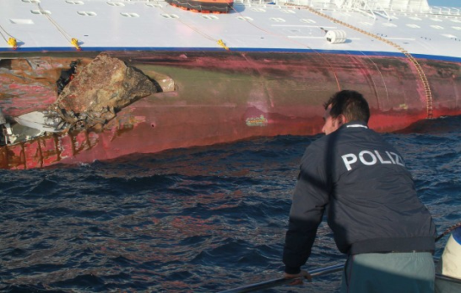
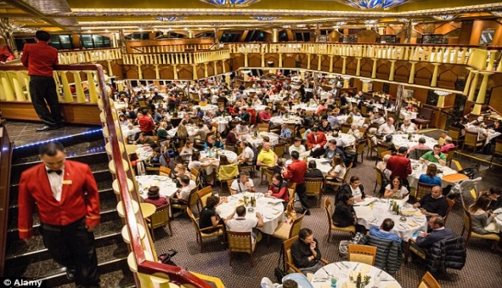
NN
NN
N°
N°

…………………………………………………………………………………….. ……………………………………………………………………………………………
…………………………………………………………………………………….. ……………………………………………………………………………………………
…………………………………………………………………………………….. …………………………………………………………………………………………..
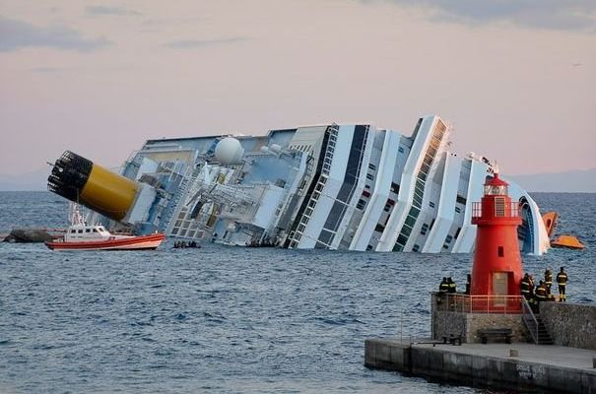
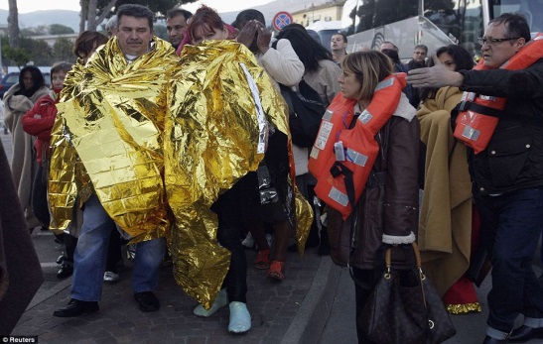
NN
NN
N°
N°

…………………………………………………………………………………….. ……………………………………………………………………………………………
…………………………………………………………………………………….. ……………………………………………………………………………………………
…………………………………………………………………………………….. …………………………………………………………………………………………..
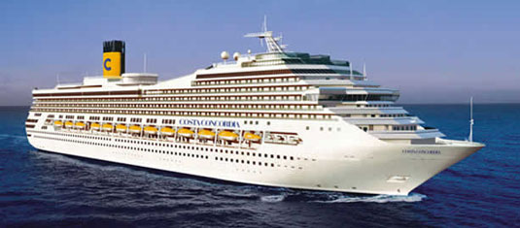
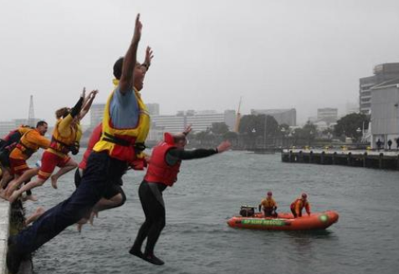

NN
N°
NN
N°

…………………………………………………………………………………….. ……………………………………………………………………………………………
…………………………………………………………………………………….. ……………………………………………………………………………………………
…………………………………………………………………………………….. …………………………………………………………………………………………..

http://www.sailworld.com/Safer_Boating_Week__Big_leap_for_safety_into_chilly_Wellington_Harbour/127873
dailymail.co.uk and Reuters

Caption : légende

