 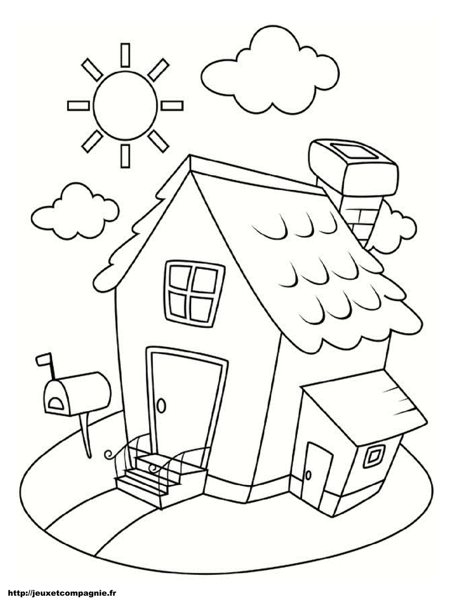 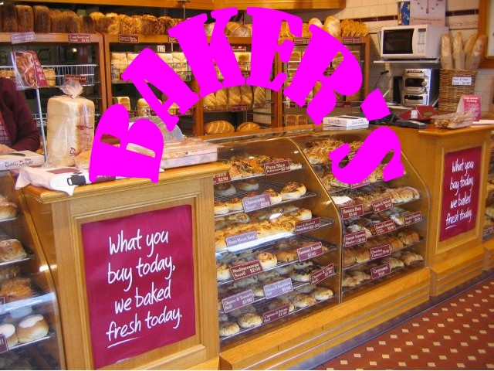

££££

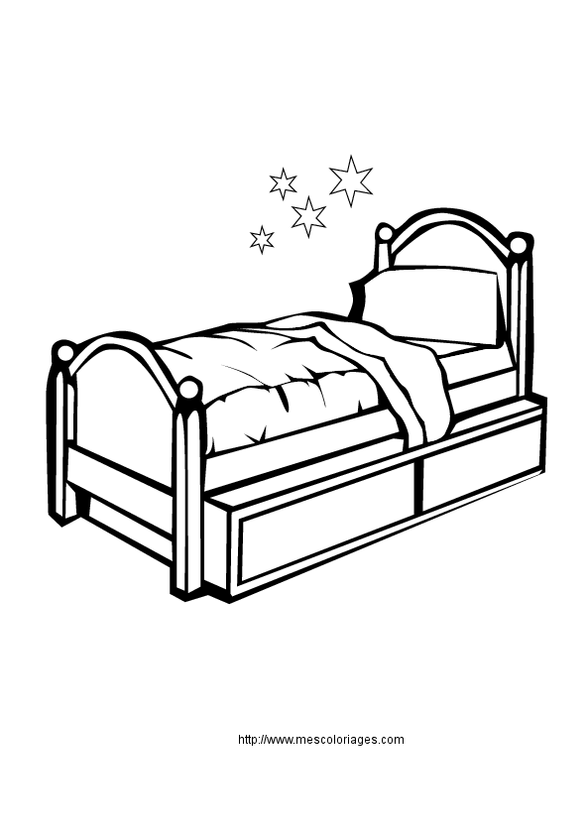

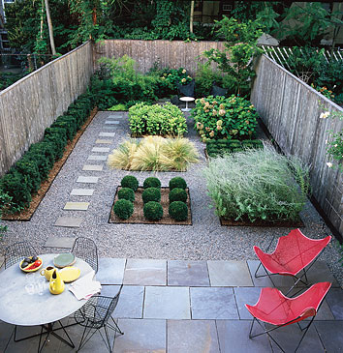

1



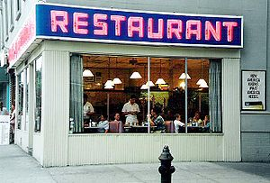



£





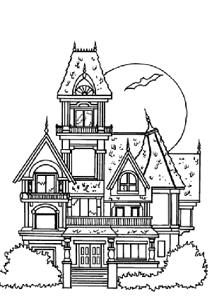



2

££££££££££



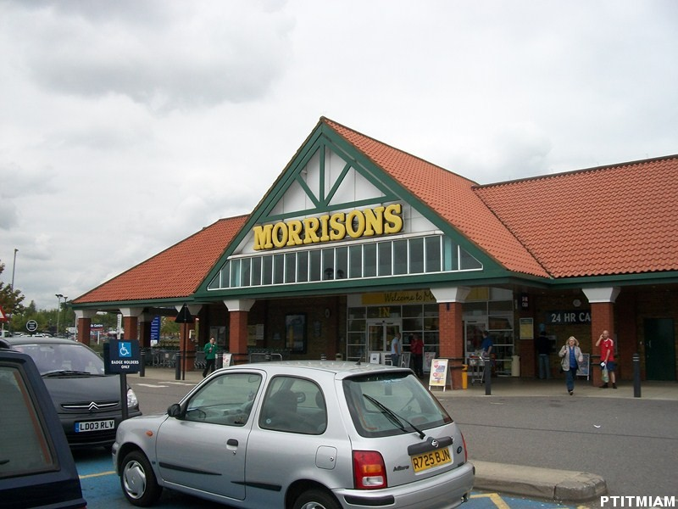 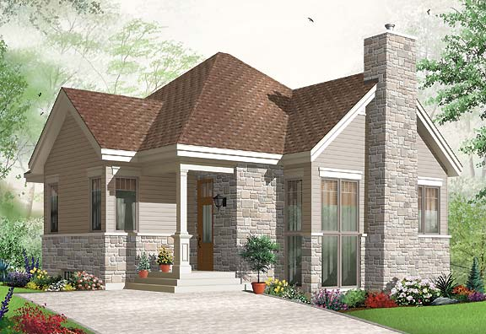

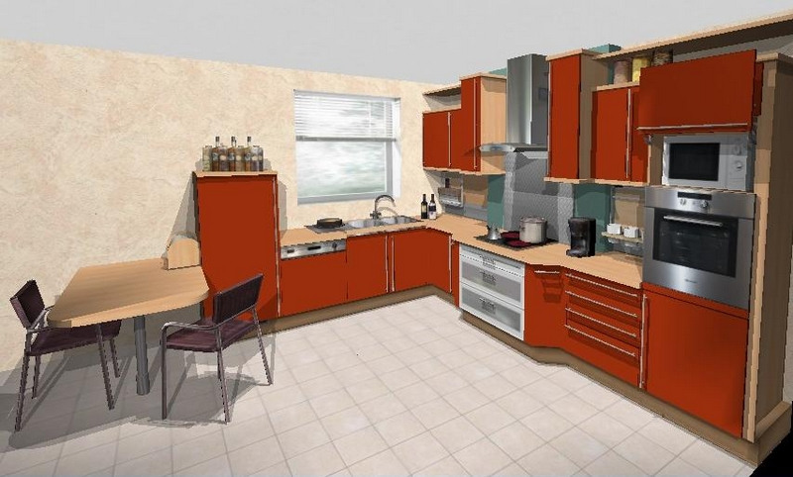

3

Name :………………………………………………………………………… Date :………………………………………………………………………….………

Travail individuel

**1. Monsieur Mason cherche une maison proche de son nouveau travail, un ami lui a envoyé les petites annonces immobilières du journal local…**



**2. Lis les petites annonces, surligne les informations que tu comprends et note-les dans le tableau. Indique comment tu as fais pour les comprendre.**

|  |  |
| --- | --- |
| Information | Comment tu as compris |
|  |  |

Remarques :………………………………………………………………………………………………………………………………………………………………………………………………………………………………………………………………………………………………………………………………………………………………………………………………………………………………………………………………………………………………………………………………………

……………………………………………………………………………………………………………………………………………………………………………………

…………………………………………………………………………………………………………………………………………………………………………………………………………………………………………………………………………………………………………………………………………………………………………

……………………………………………………………………………………………………………………………………………………………………………………

Names :………………………………………………………………………………………………………………………………………………………………………………….. Date :………………………………………………………………………….………

Travail de groupe

3. Ensemble, **après vous être mis d’accord**, complétez le tableau avec les informations trouvées.

|  |  |
| --- | --- |
| Information | Comment vous avez compris |
|  |  |

**Remarques** :………………………………………………………………………………………………………………………………………………………………………………………………………………………………………………………………………………………………………………………………………………………………………………………………………………………………………………………………………………………………………………………………………

…………………………………………………………………………………………………………………………………………………………………………………………………………………………………………………………………………………………………………………………………………………………………………

**4. Essayez de trouver la photo qui correspond à chaque annonce**

…………………………………………………………………………………………………………………………………………………………………………………………………………………………………………………………………………………………………………………………………………………………………………

……………………………………………………………………………………………………………………………………………………………………………………

**L’ami de Monsieur Mason lui a ensuite envoyé les annonces en anglais ! Vérifiez que vous avez bien compris.**

There is a house between a school and a baker’s and it is cheap. The address is Old Lane. There are three bedrooms and a small garden.



  

££££



1

There is a house near a restaurant and a big supermarket. It is very cheap. The address is Park Avenue. There are three bedrooms and a big garden. But it is haunted!



-









£



2

There is a house opposite the supermarket, but it’s expensive. The address is High Street. There are five bedrooms and a modern kitchen.

££££££££££



 



3

**Répondez ensuite à la question :**

Mr Mason wants a quiet house near a lot of shops and he doesn’t believe in ghosts. Which house does he want to visit?

................................................................................................................................................................................................................................................................................................................................................................................

................................................................................................................................................................................................................................................................................................................................................................................