**A – WARMING UP**

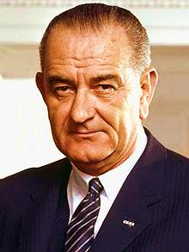 **1 – Who are these people? Please, write their names**

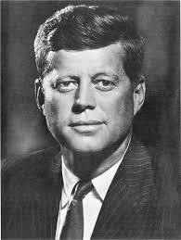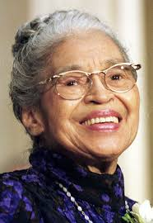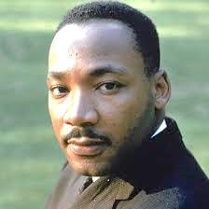

**…………………………………. ……………………………… ………………………………….. ………………………….**

**2 – What have they got in common?**

…………………………………………………………………………………………………………………………………………………

**B – VOCABULARY**

**1 - Find a definition for the following words (the answers are all in the video you’ve watched).**

a – Segregation:……………………………………………………………………………………………………………………………….

b – Slavery: ………………………………………………………………………………………………………………………………………….

c – Abolitionists: ………………………………………………………………………………………………………………………………..

d – Civil war: ………………………………………………………………………………………………………………………………………..

e – Discrimination: ……………………………………………………………………………………………………………………………..

…………………………………………………………………………………………………………………………………………………………………

f – Prejudice: ……………………………………………………………………………………………………………………………………….

g – Boycott: ………………………………………………………………………………………………………………………………………….

h – Emancipation: ……………………………………………………………………………………………………………………………….

**2 – Can you explain what are:**

a – the 13th Amendment: ……………………………………………………………………................................................

b – the Jim Crow laws: ……………………………………………………………………………………………………………………..

…………………………………………………………………………………………………………………………………………………………………

………………………………………………………………………………………………………………………………………………………………..

c – the separate but equal doctrine: ……………………………………………………………………………………………

………………………………………………………………………………………………………………………………………………………………..

d – the Ku Klux Klan: …………………………………………………………………………………………………………………………

…………………………………………………………………………………………………………………………………………………………………

e – the NAAPC: ………………………………………………………………………………………………………………………………….

**3 – What happened in:**

a - 1947: ………………………………………………………………………………………………………………………………………………

b - 1948: ………………………………………………………………………………………………………………………………………………

c - 1954: ………………………………………………………………………………………………………………………………………………

d - 1964: ………………………………………………………………………………………………………………………………………………

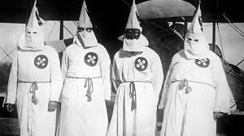

**C – MARTIN LUTHER KING**

**I – What do you know about him?**

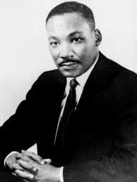



**II – Fill in the grid with information from the video (**[**watchmopjo.com**](watchmojo.com)**)**

|  |  |  |  |
| --- | --- | --- | --- |
| Date of birth |  | | |
| Education |  | | |
| Main Activity |  | | |
| Reason of his celebrity |  | | |
| Family | Father’s occupation |  | |
| Wife’s name |  | |
| Name of the association he was president of |  | | |
| Actions and dates |  | | |
| Death | Date | |  |
| Place | |  |
| Way he died | |  |
| Name of the killer | |  |
| Distinction |  | | |

**III – Watch the slides and complete your knowledge on Martin Luther King (by DON FISHER)**

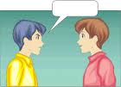**IV – Pair work.**

**Student A:** you’re a journalist interviewing Martin Luther King.

**Student B**: you’re Martin Luther King and you answer the journalist’s questions.

Please, have look at **the grammar kit.**

**V –Listen to Martin Luther King’s speech and fill in the blanks.**

|  |
| --- |
| “(… ) Go back to Mississippi, go back to**…………………………………………….**, go back to South Carolina, go back to Louisiana, go back to the *slums* 1 and **…………………………………………** of our Northern countries, knowing that *somehow* 2 this situation can and will be**…………………………………………**. Let us not *wallow* 3 in the valley of…………………………………………. |
| I say to you today, my friends, *though*4, even though we face the **……………………………………………………….**of today and tomorrow, I still have a……………………………………………… . It’s a dream *deeply rooted*  5 in the……………………………………………………dream. I have a dream that one day this nation will**……………………………… ……………….**, live out the true meaning of its *creed*  6 : “ We hold these truths to the self- evident, that all men are**………………………………………………………….**”. |
| I have a dream that one day on the red hills of Georgia sons of *former* 7………………………………………………….. and the sons of former-owners will be able to sit down together at the table of**…………………………………………………………**. I have a dream that one day even the state of Mississippi, a state of *sweltering* with the *heat* 8 of**……………………………………………**, sweltering with the heat of**………………………………………………….**, will be transformed into an oasis of **…………………………………………………**and…………………………………………. |
| I have a dream that my four little ……………………………………………will one day live in a nation where there will be not……………………………………………….by the color of their **………………………………………………**but by the content of their**………………………………………………………**. I have a dream that one day in Alabama, with its vicious…………………………………………., with its governor having his **…………………………………………………..***dripping* 9 with thewords of interposition and nullification, one day there in Alabama little black boys and girls will be able to join hands with little white boys and white girls as………………………………… and …………………………………………(…)”.  **SPEECH BY THE REV. MARTIN LUTHER KING AT THE MARCH ON WASHINGTON.** |
|  |

**WORD BANK**: *1 – Slums =* very deprived urban areas / 2 – Somehow = by some manner / *3 – Wallow:* se complaire dans / *4- Though =* even if / *5 – Deeply* rooted: profondément enraciné / *6 - Creed* = belief: foi / *7 – Previous* = former / *8 – Sweltering heat*: chaleur accablante / *9 – Dripping:* trempé

**D – MARTIN LUTHER KING’S LEGACY**

**I – Was Martin Luther King Civil Rights movement successful?**

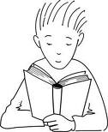 **Read the text and answer the questions in French.**

**Extract from President Lyndon B. Johnson's**

**Radio and Television Remarks upon Signing the Civil Rights Bill**

**July 2, 1964**

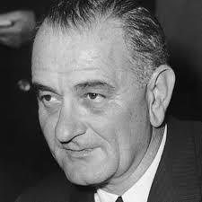[Broadcast from the East Room at the White House at 6:45 p.m.]

My fellow Americans:

I am about to sign into law the Civil Rights Act of 1964. I want to take this occasion to talk to you about what that law means to every American. (…)

Americans of every race and color have died in battle to protect our freedom. Americans of every race and color have worked to build a nation of widening opportunities. Now our generation of Americans has been called on to continue the unending search for justice within our own borders.

We believe that all men are created equal. Yet many are denied equal treatment.

We believe that all men have certain unalienable rights. Yet many Americans do not enjoy those rights.

We believe that all men are entitled to the blessings of liberty. Yet millions are being deprived of those blessings--not because of their own failures, but because of the color of their skin.

The reasons are deeply imbedded in history and tradition and the nature of man. We can understand--without rancor or hatred--how this all happened.

But it cannot continue. Our Constitution, the foundation of our Republic, forbids it. The principles of our freedom forbid it. Morality forbids it. And the law I will sign tonight forbids it.

That law is the product of months of the most careful debate and discussion. It was proposed more than one year ago by our late and beloved President John F. Kennedy. It received the bipartisan support of more than two-thirds of the Members of both the House and the Senate. An overwhelming majority of Republicans as well as Democrats voted for it.

It has received the thoughtful support of tens of thousands of civic and religious leaders in all parts of this Nation. And it is supported by the great majority of the American people.

The purpose of the law is simple.

It does not restrict the freedom of any American, so long as he respects the rights of others.

It does not give special treatment to any citizen.

It does say the only limit to a man's hope for happiness, and for the future of his children, shall be his own ability.

It does say that there are those who are equal before God shall now also be equal in the polling booths, in the classrooms, in the factories, and in hotels, restaurants, movie theaters, and other places that provide service to the public.

I am taking steps to implement the law under my constitutional obligation to "take care that the laws are faithfully executed." (…)

1 – Quel est le type de ce document?

…………………………………………………………………………………………………………………………………………………………………

2 – Quand, où et à quelle occasion a-t-il été diffusé ?

…………………………………………………………………………………………………………………………………………………………………

…………………………………………………………………………………………………………………………………………………………………

3 – Quel en est son auteur ? Quelle activité exerçait-il alors ?

…………………………………………………………………………………………………………………………………………………………………

4 – Quel est le thème principal abordé dans ce document ?

………………………………………………………………………………………………………………………………………………………………..

5 – Pourquoi la situation actuelle ne peut-elle pas perdurer ?

…………………………………………………………………………………………………………………………………………………………………

6 – Qui et quand est à l’origine de cette action ? A quel moment a-t-elle déjà été proposée ?

…………………………………………………………………………………………………………………………………………………………………

7 – Sur quels sont les actes concrets de la vie quotidienne ce texte débouche-t-il ?

…………………………………………………………………………………………………………………………………………………………………

…………………………………………………………………………………………………………………………………………………………………



**II – MARTIN LUTHER KING’S DAY**

**a - Watch the video (by [Learn English Holidays.com](learn%20English%20Holidays.com)) and answer the quiz.**

1 – La journée réservée à Martin Luther King est célébrée le :

□ 3 janvier □ 13 janvier □ 30 janvier

2 – □ Les 50 états américains ont tous immédiatement acceptés de célébrer cette journée.

□ Certains états seulement ont accepté de célébrer cette journée.

□ Aucun des 50 états américains n’a accepté de célébrer cette journée.

3 – La loi officialisant cette journée a été signée en □ 1993 □ 1983 □2003

4 - □Toutes les villes américaines préparent des actions en l’honneur de ce jour.

□ Rien n’est organisé en particuliers dans les états américains.

□ Seuls certains états américains mettent en place des actions particulières.

5 – □ Ce jour-là, les américains célèbrent à la fois les droits acquis par les afro américains que la façon dont Martin Luther King s’y est pris pour les acquérir.

□ Ce jour-là, seule la façon dont Martin Luther King s’y est pris pour faire acquérir des droits aux noirs est célébrée.

□ Ce jour-là, seuls les droits des afro américains sont célébré s?

6 – □ Cette journée n’est célébrée qu’aux Etats-Unis.

□ Cette journée est célébrée dans d’autres pays.

7 – Les états américains ont tous honoré cette loi en □ 1990 □ 2000 □ 2010

8 – Cette loi a été promulguée par le président □ Clinton □ Reagan □ Bush



**b – Watch the video and complete the chart.**

**1 - Answer these questions.**

**Pick up 4 activities American people can do during that day.**

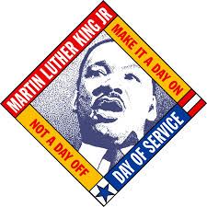**………………………………………………………………………………………………………………………**

**………………………………………………………………………………………………………………………**

**………………………………………………………………………………………………………………………**

**………………………………………………………………………………………………………………………………………………….**

**2 - What sorts of people do these activities?**

**…………………………………………………………………………………………………………………………………………………**

**E – MARTIN LUTHER KING’S 50th ANNIVERSARY.**

**1 - Observe and comment the cartoons.**

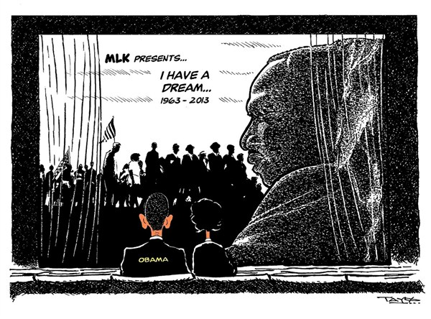

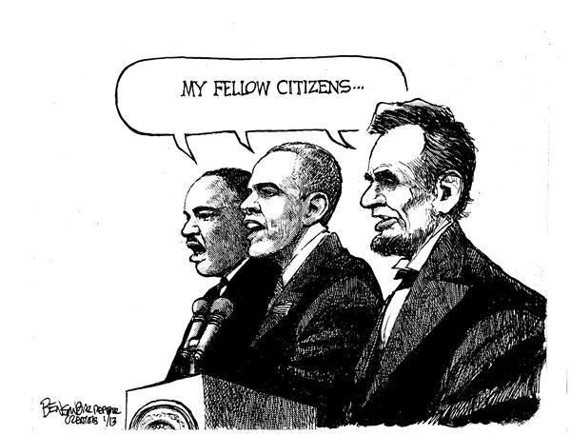



**2 – Watch the slides and compare Martin Luther King with Barack Obama. Use the vocabulary given below.**

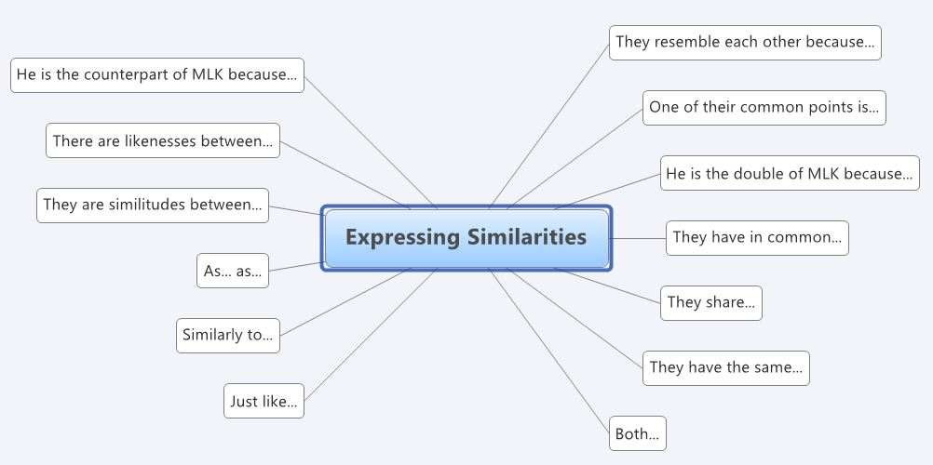

**Then, write down your answers on the chart.**

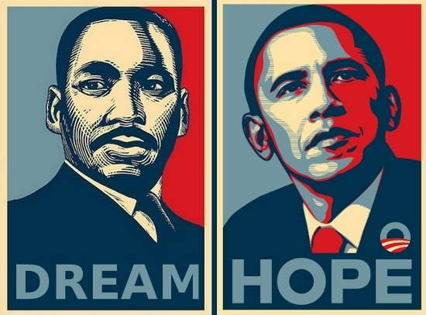

**WHAT ARE THE COMMON POINTS BETWEEN MARTIN LUTHER KING AND BARACK OBAMA**

|  |
| --- |
|  |
|  |
|  |
|  |
|  |
|  |
|  |
|  |
|  |
|  |
|  |
|  |
|  |
|  |
|  |

[http://www.bet.com/news/national/photos/2011/08/king-and-obama-11-things-in-common.html#!081111-news-obama-martin-luther-king-jr-10](http://www.bet.com/news/national/photos/2011/08/king-and-obama-11-things-in-common.html" \l "!081111-news-obama-martin-luther-king-jr-10)



**3 – Watch the video about Obama’s tribute to Martin Luther King. (From CNN)**

**Tick the right answer.**

a – 60 years ago about a quarter million people marched on Washington.

▫ RIGHT ▫WRONG

b – There was so much fear: people afraid to be afraid. ▫ RIGHT ▫WRONG

c – Our country is worse and we are worse. ▫ RIGHT ▫WRONG

d – We still have a distance to go. . ▫ RIGHT ▫WRONG

e – President Obama said that it was enough to have a black president.

▫ RIGHT ▫WRONG

f – Each generation seems wiser in terms of treating people fairly, do the right thing and not discriminating.

▫ RIGHT ▫WRONG

**F - RECAP**

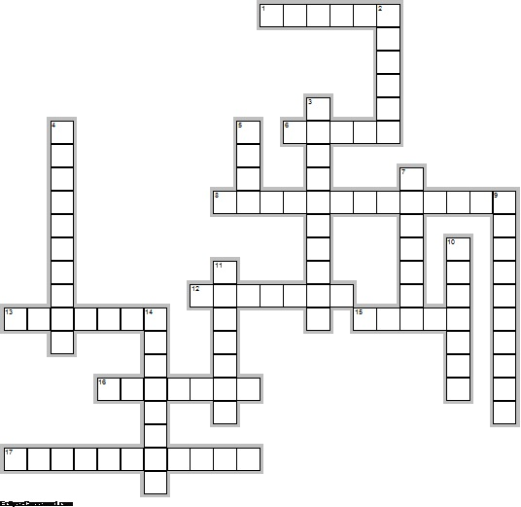

**Across**

2. Martin Luther King's wife first name

5. Country where Martin Luther King Day is also celebrated

7. Name of the memorial where Martin Luther King pronounced his famous speech

9. Fact of separating citizens according to the color of their skin

11. Martin Luther King's activity

12. Name of the lady who participated to the bus boycott

14. Name of the organization Martin Luther King was president of

16. Name of the singer who was in favor of Martin Luther King's Day

**Down**

1. Martin Luther King's birthplace

3. Name of the president who made Martin Luther King's Day a national holiday

4. Place where the famous boycott took place

6. President's name who signed the Civil Rights Act.

8. Martin Luther King's murderer

9. Way Martin Luther King died

10. Place where the March took place in 1963

13. What Martin Luther King's Day is for?

15. Way of protesting against something

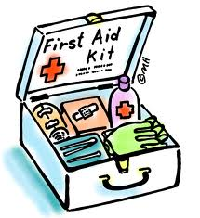**G – GRAMMAR KIT**

**1 - Le Prétérit simple en anglais adapted from** [**http://www.anglaiscours.fr/**](http://www.anglaiscours.fr/)

**Quand l'utiliser?**

On utilise le **prétérit** pour parler d'une action dans un **passé révolu**, c'est à dire quand l'action est clairement définie dans le passé et qu'il n'y a pas de lien avec le présent. Souvent, il y a une date ou un marqueur de temps comme "yesterday", "last week", "two years ago" etc.

**Comment le construire?**

Pour les verbes réguliers, il suffit de prendre la base verbale, et de rajouter **ED** à la fin du verbe. Par exemple, le verbe to walk *marcher*, donnera walk**ed**.

I walk**ed**, you walk**ed**, he/she walk**ed**, we walk**ed**, you walk**ed**, they walk**ed**.

Il y a beaucoup de verbes irréguliers, qui, au lieu de se finir en ED, prennent une autre forme de terminaison. Par exemple, le verbe **to think** ne donnera pas ~~thinked~~ mais **thought**. Le verbe **to see** ne donnera pas ~~seeed~~ mais **saw**.

Pour connaître les verbes irréguliers, il n'y a pas de secret, il faut les apprendre en prenant une liste des verbes et en les mémorisant méthodiquement. (voir liste des verbes irréguliers à la fin du document).

**La forme interrogative.**

On a besoin d'**un auxiliaire** pour mettre une phrase à la forme interrogative et négative.

Au prétérit, c'est tout simplement l'auxiliaire qui se met au prétérit.

Par exemple : **Did** you like the movie ?

DID est le prétérit de l'auxiliaire DO.

Autre exemple : **Were** you happy yesterday ?

WERE est le prétérit de l'auxiliaire BE (= WAS (to be au passé) à la 3 ème personne du singulier)

**La forme négative.**

Pour la forme négative, c'est la même chose. C'est l'auxiliaire qui prend la marque du prétérit.

I **did not** like the movie ou I **didn't** like the movie.(DID + NOT)

I **was not** happy yesterday ou I **wasn't** happy yesterday. (WAS + NOT)

**2 - LISTE DES VERBES IRREGULIERS.**

| **INFINITIF** | **PRÉTÉRIT** | **PARTICIPE PASSE** |
| --- | --- | --- |
| **arise** s'élever | arose | arisen |
| **be** être | was / were | been |
| **beat** battre | beat | beaten |
| **become** devenir | became | become |
| **begin** commencer | began | begun |
| **bend** plier, courber | bent | bent |
| **bet** parier | bet | bet |
| **bind** lier | bound | bound |
| **bleed** saigner | bled | bled |
| **blow** souffler | blew | blown |
| **break** casser | broke | broken |
| **bring** amener | brought | brought |
| **build** construire | built | built |
| **burn** brûler | burnt | burnt |
| **burst** éclater | burst | burst |
| **buy** acheter | bought | bought |
| **cast** jeter, lancer | cast | cast |
| **catch** attraper | caught | caught |
| **choose** choisir | chose | chosen |
| **cling** s'accrocher | clung | clung |
| **come** venir | came | come |
| **cost** coûter | cost | cost |
| **creep** ramper | crept | crept |
| **cut** couper | cut | cut |
| **deal** s'occuper de | dealt | dealt |
| **dig** creuser | dug | dug |
| **do** faire | did | done |
| **draw** dessiner | drew | drawn |
| **dream** rêver | dreamt | dreamt |
| **drink** boire | drank | drunk |
| **drive** conduire | drove | driven |
| **eat** manger | ate | eaten |
| **fall** tomber | fell | fallen |
| **feed** nourrir | fed | fed |
| **feel** sentir, ressentir | felt | felt |
| **fight** se battre | fought | fought |
| **find** trouver | found | found |
| **fling** lancer violemment | flung | flung |
| **fly** voler | flew | flown |
| **forbid** interdire | forbade | forbidden |
| **forget** oublier | forgot | forgotten |
| **forgive** pardonner | forgave | forgiven |
| **freeze** geler | froze | frozen |
| **get** obtenir, devenir... | got | got |
| **give** donner | gave | given |
| **go** aller | went | gone |
| **grind** moudre | ground | ground |
| **grow** grandir | grew | grown |
| **hang** suspendre | hung | hung |
| **have** avoir | had | had |
| **hear** entendre | heard | heard |
| **hide** (se) cacher | hid | hidden |
| **hit** frapper | hit | hit |
| **hold** tenir | held | held |
| **hurt** faire mal, | hurt | hurt |
| **keep** garder | kept | kept |
| **kneel** s'agenouiller | knelt | knelt |
| **know** savoir, connaître | knew | known |
| **lay** étaler, disposer | laid | laid |
| **lead** mener | led | led |
| **learn** apprendre | learnt | learnt |
| **leave** quitter, laisser | left | left |
| **lend** prêter | lent | lent |
| **let** permettre, laisser | let | let |
| **lie** être étendu | lay | lain |
| **light** allumer | lit | lit |
| **lose** perdre | lost | lost |
| **make** faire | made | made |
| **mean** signifier, vouloir dire | meant | meant |
| **meet** rencontrer | met | met |
| **pay** payer | paid | paid |
| **put** mettre | put | put |
| **read** lire | read | read |
| **ride** faire (du cheval, du vélo) | rode | ridden |
| **ring** sonner | rang | rung |
| **rise** se lever | rose | risen |
| **run** courir | ran | run |
| **say** dire | said | said |
| **see** voir | saw | seen |
| **seek** chercher | sought | sought |
| **sell** vendre | sold | sold |
| **send** envoyer | sent | sent |
| **set** fixer | set | set |
| **sew** coudre | sewed | sewn |
| **shake** secouer | shook | shaken |
| **shine** briller | shone | shone |
| **shoot** tirer (pistolet) | shot | shot |
| **show** montrer | showed | shown |
| **shrink** se rétrécir | shrank | shrunk |
| **shut** fermer | shut | shut |
| **sing** chanter | sang | sung |
| **sink** couler | sank | sunk |
| **sit** être assis | sat | sat |
| **slay** tuer | slew | slain |
| **sleep** dormir | slept | slept |
| **slide** glisser | slid | slid |
| **smell** sentir | smelt | smelt |
| **speak** parler | spoke | spoken |
| **spell** épeler | spelt | spelt |
| **spend** passer (temps), dépenser | spent | spent |
| **spill** répandre | spilt | spilt |
| **spin** tourner | spun | spun |
| **spit** cracher | spat | spat |
| **split** se séparer, se fendre | split | split |
| **spread** étaler | spread | spread |
| **spring** jaillir | sprang | sprang |
| **stand** être debout | stood | stood |
| **steal** voler | stole | stolen |
| **stick** coller | stuck | stuck |
| **sting** piquer | stung | stung |
| **stink** puer | stank | stunk |
| **strike** frapper | struck | struck |
| **swear** jurer | swore | sworn |
| **sweep** balayer | swept | swept |
| **swim** nager | swam | swum |
| **swing** se balancer | swung | swung |
| **take** prendre | took | taken |
| **teach** enseigner | taught | taught |
| **tear** déchirer | tore | torn |
| **tell** raconter | told | told |
| **think** penser | thought | thought |
| **throw** jeter | threw | thrown |
| **tread** fouler aux pieds | trod | trodden |
| **undergo** subir | underwent | Undergone |
| **understand** comprendre | understood | understood |
| **wake up** se réveiller | woke up | woken up |
| **wear** porter (habits) | wore | worn |
| **weave** tisser | wove | woven |
| **weep** pleurer | wept | wept |
| **win** *gagner* | won | won |
| **wind** serpenter | wound | wound |
| **withdraw** se retirer | withdrew | withdrawn |
| **wring** tordre | wrung | wrung |
| **write** écrire | wrote | written |

**3 - Prononciation du -ED final au prétérit (from anglaisfacile.com)**

La prononciation change en fonction du son final du radical du verbe:

Par exemple,   
'play' se termine par le son /ei/  
'start' se termine par le son /t/ etc.

Attention, on parle bien du son final et non de la dernière lettre finale. On doit s'intéresser AU SON et non A LA LETTRE.  
  
Exemple:

le verbe 'fix' se termine par le son /s/, car, phonétiquement, il s'écrit et se prononce /fiks/

Une fois qu'on a identifié ce son final, il est très facile de savoir comment le prononcer:

/d/ en règle générale, c'est-à-dire qu'on le prononce comme s'il y avait un 'd' à la fin. C'est le cas pour: lived, arrived, enjoyed, played...  
  
-> /t/ après certains sons : si le verbe se termine par le son /p/, /k/, /f/, /s/, http://www.anglaisfacile.com/free/images/api3/21.gif, http://www.anglaisfacile.com/free/images/api3/22.gif. Exemples:  
worked (son /k/), watched (http://www.anglaisfacile.com/free/images/api3/22.gif), stopped (/p/), washed (http://www.anglaisfacile.com/free/images/api3/23.gif)  
  
-> /id/ après les sons /d/ et /t/. Exemples: decided, started, wanted, needed

**4 - Le prétérit en BE+-ING (from anglaisfacile.com)**

**Emploi:** il exprime une action en progression dans le passé, une action qui était en train de se dérouler quand une autre action s'est enclenchée.

**Construction:**

|  |
| --- |
| auxiliaire BE au prétérit (was/were) + ING Base Verbale (l'infinitif sans TO) + |

**Exemples:**  
Were they playing football when you saw them yesterday?

(sens: les enfants étaient-ils en train de jouer au football hier, au moment où vous les avez vus ?)

**Réponses:**  
Yes, they were playing football when I saw them yesterday.  
= Yes, they were.

No, they weren't playing football when I saw them yesterday.  
= No, they weren't.

**EXERCISES**

**THE PAST**

|  |
| --- |
|  |

**1 - Conjugue le verbe entre parenthèse au PRETERIT simple.**

1. ______________________________ (you/go) to London yesterday?   
2. Yes, I ______________________________ (réponse courte)  
3. I ______________________________ (take) the Eurostar   
4. and I ______________________________ (arrive) at Waterloo Station.   
5. I ______________________________ (meet) old friends there.   
6. They ______________________________ (be) all very happy to see me.   
7. I ______________________________ (visit) the town with them.   
8. I even ______________________________ (see) Prince Charles!   
9. I ______________________________ (go) to Buckingham Palace too!   
10. It ______________________________ (be) a wonderful journey!

**2 - Même exercice que précédemment (adapted from anglaisfacile.com)**

1. She …………………………………………………..(write) to her friend Kevin.  
  
2. Yesterday, he ……………………………………(play) football with Julien.

3. I …………………………………………………………(speak) to my uncle on the phone.  
  
4. Mary …………………………………………………(buy) a present for Camilla 2 days ago.  
  
5. My mother …………………………………………(be) there yesterday.

6. Did your mother ………………………………………….(drive) you to school?  
  
7. He ……………………………………………………….(bring) sweets for the pupils.  
  
8. I …………………………………………………………(work) in this supermarket when I was 16.  
  
9. He ………………………………………………….(leave) five minutes ago.  
  
10. Sylvia …………………………………………………(teach) Spanish some years ago.

**3 - Ecris à côté de chaque verbe s’il se prononce par un /d/, /t/ ou /id/.**

1. listened: …………………………………… 6. closed: …………………………..  
2. cleaned: …………………………………… 7. accepted: ……………………….  
3. looked: …………………………………….. 8. smoked: ……………………………  
4. worked: ……………………………………  
5. wanted: ……………………………………

**4 – Conjugue les verbes entre parenthèses au PRETERIT SIMPLE ou au PRETERIT en BE + V-ING (from anglaisfacile.com).**

a -I ______________________________ (have) a bath yesterday   
when the phone ______________________________ (ring).

b - ' That must be my mother,' I ______________________________ (think).   
c - As I ______________________________ (get) out of the bath,   
I ______________________________ (put) my foot on my watch   
and I ______________________________ (break) it.   
d - The phone ______________________________ (still/ring).   
e - I ______________________________ (run) out of the bathroom   
and I ______________________________ (hit) my head on the floor.   
f - It ______________________________ (hurt) terribly   
and I ______________________________ (want) to sit down for a moment   
but the phone ______________________________ (still/ring).   
g - ' Please wait a minute, mother,' I ______________________________ (think).   
h -The cats ______________________________ (sit) at the top of the stairs.   
i - I ______________________________ (not/see - forme contractée) them   
and I ______________________________ (fall).   
j - At the bottom of the stairs, I ______________________________ (get up).   
k - My right leg ______________________________ (hurt) more than my head.   
l - The phone ______________________________ (still/ring).   
m - At last I ______________________________ (answer) it.   
n - It ______________________________ (be) my mother.   
o – ‘ Hello, dear. Is everything all right?' she ______________________________ (say).