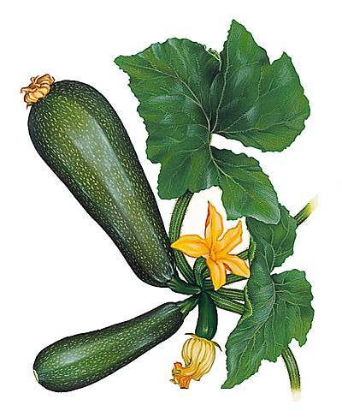 | 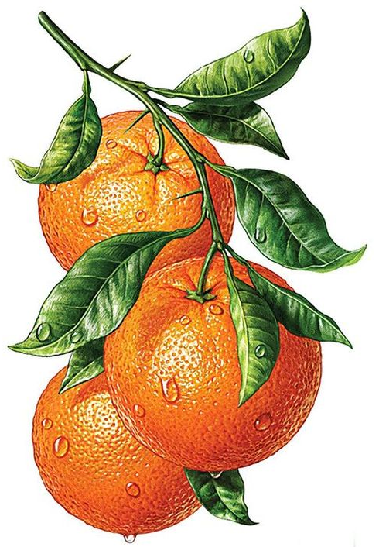  Clémentines
MAROC | CORSE | ISRAEL
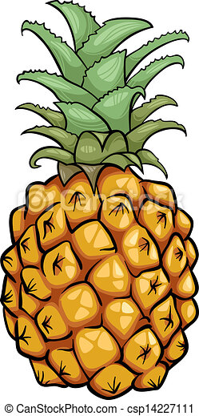 | Oranges | 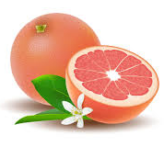  Pamplemousse
COSTA RICA | PORTUGAL | CHINE
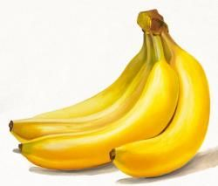 | 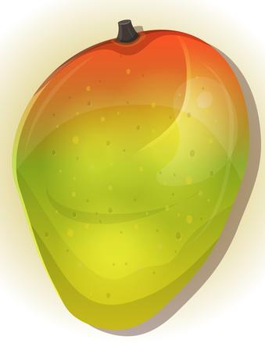  Mangue
CAMEROUN | EQUATEUR | FRANCE

 | Clémentines
ESPAGNE | ALGERIE | MAROC
 | Oranges | Pamplemousse
PHILIPPINES | TUNISIE | VIET NAM
 | Mangue
PEROU | PEROU | FRANCE

 | Clémentines
MAROC | MAROC | ISRAEL
 | Oranges | Pamplemousse
THAILANDE | ESPAGNE | CHINE
 | Mangue
COTE D’IVOIRE | PEROU | FRANCE

