Chaine de Mr Bobroff (vulgarisation)
https://www.youtube.com/user/vulgarisation
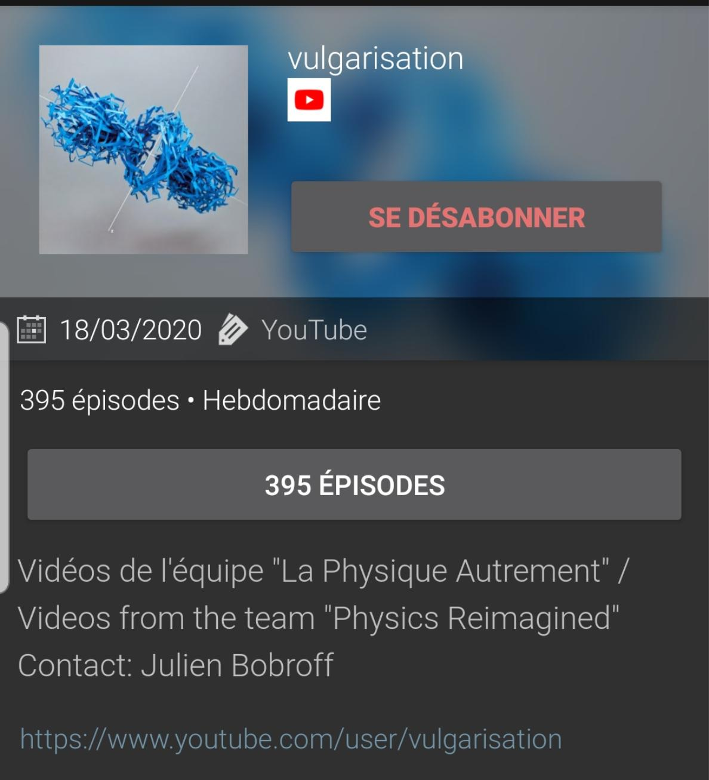

Chaine de Mr Louapre (vulgarisation)
https://www.youtube.com/user/ScienceEtonnante
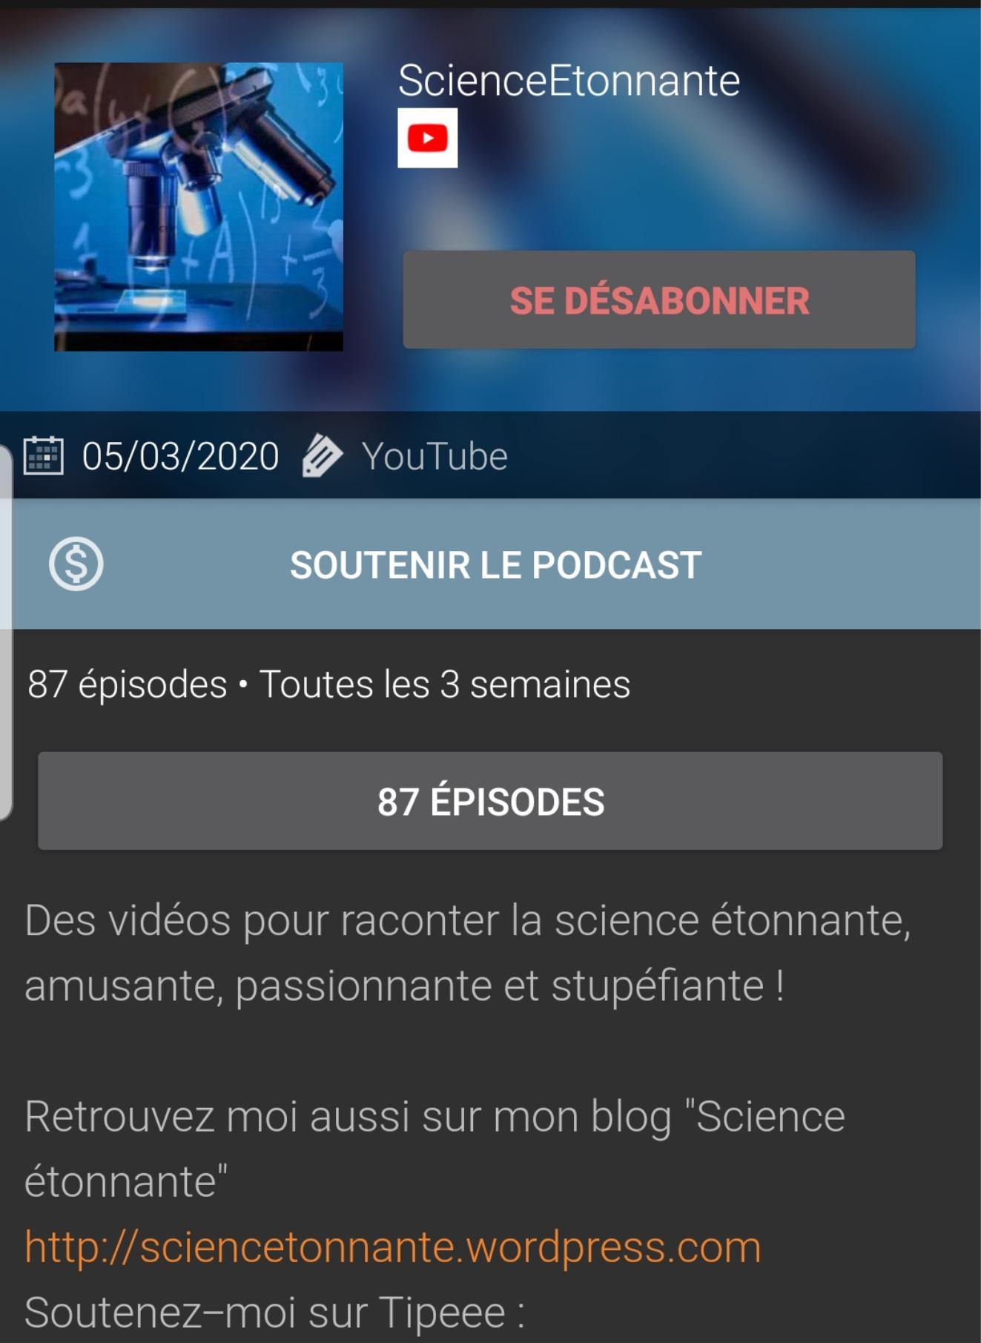

Chaine de Mme Raffin
https://www.youtube.com/channel/UCHYqoNtWTk6sR1BUXb_sERQ
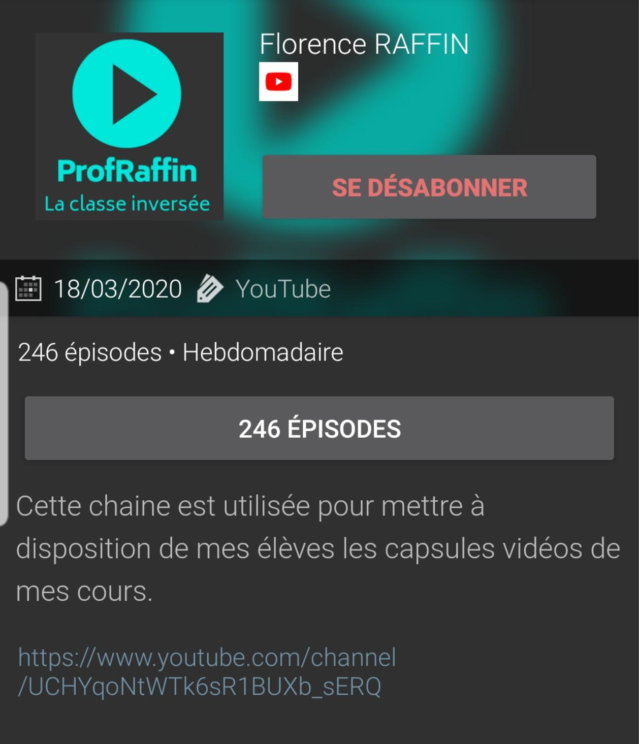

Chaine de Mr O mejean
https://www.youtube.com/channel/UCsnkSo4bqudwVUF_fzZ15_A
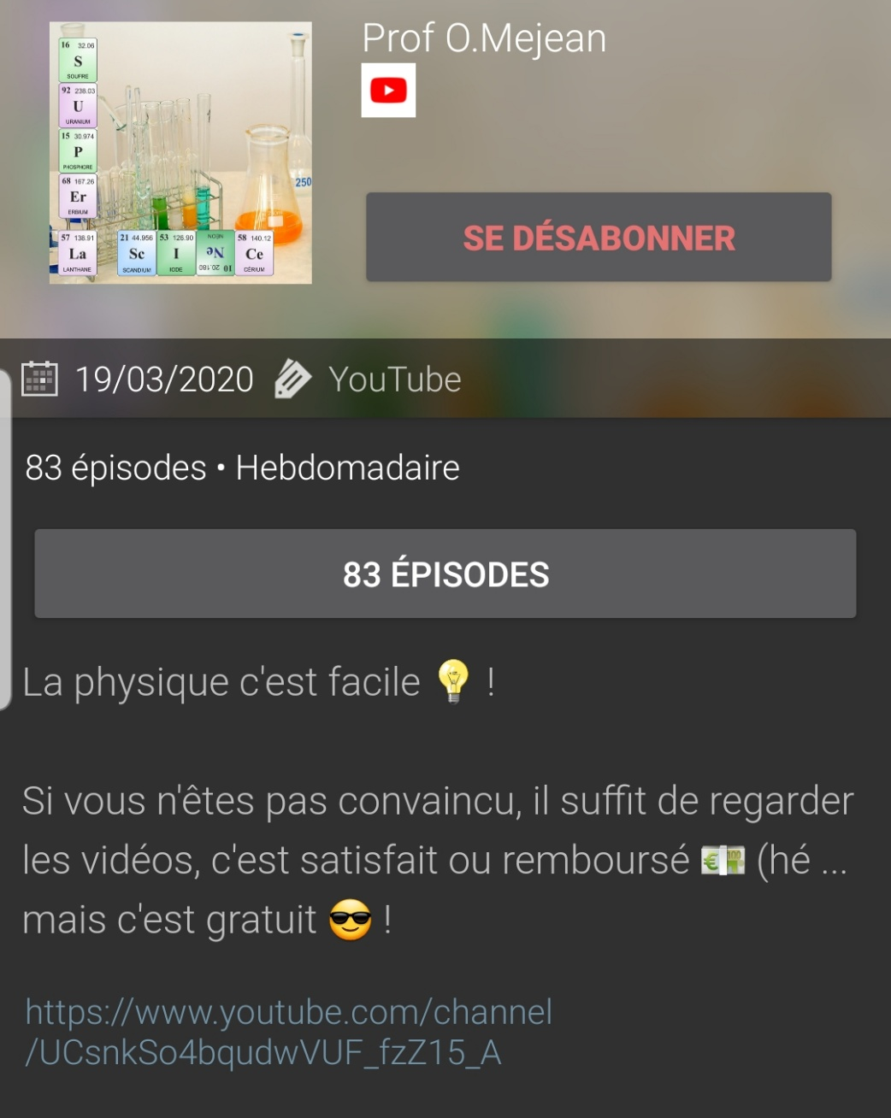

Chaine de Mme Ponsonnet
https://www.youtube.com/channel/UCk34dyG1U7rKvtsEdtOC12g
Chaine de prof :
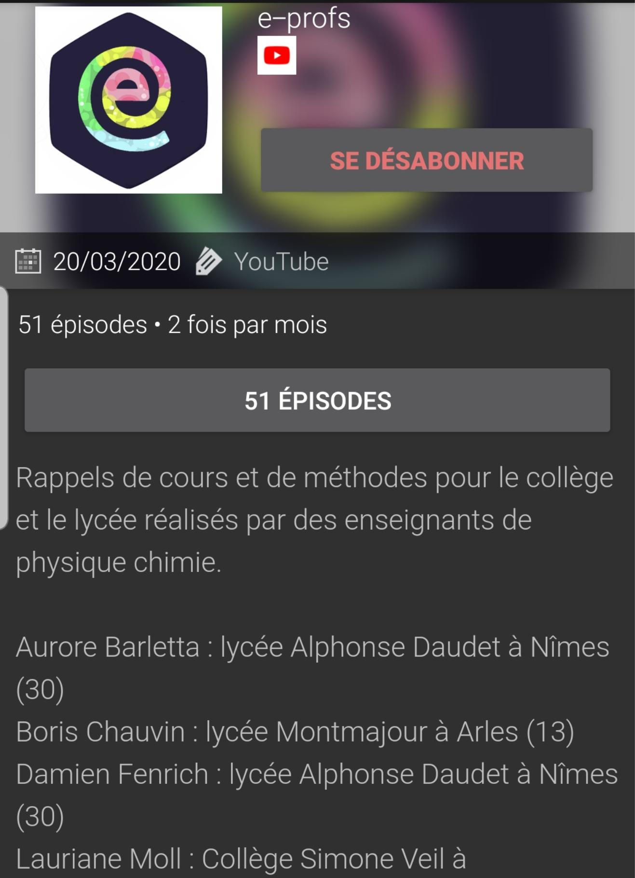
https://m.youtube.com/channel/UCe82KAmxDemlzUYVMWFJ9Bg

Chaine de Mr. Duthoit :
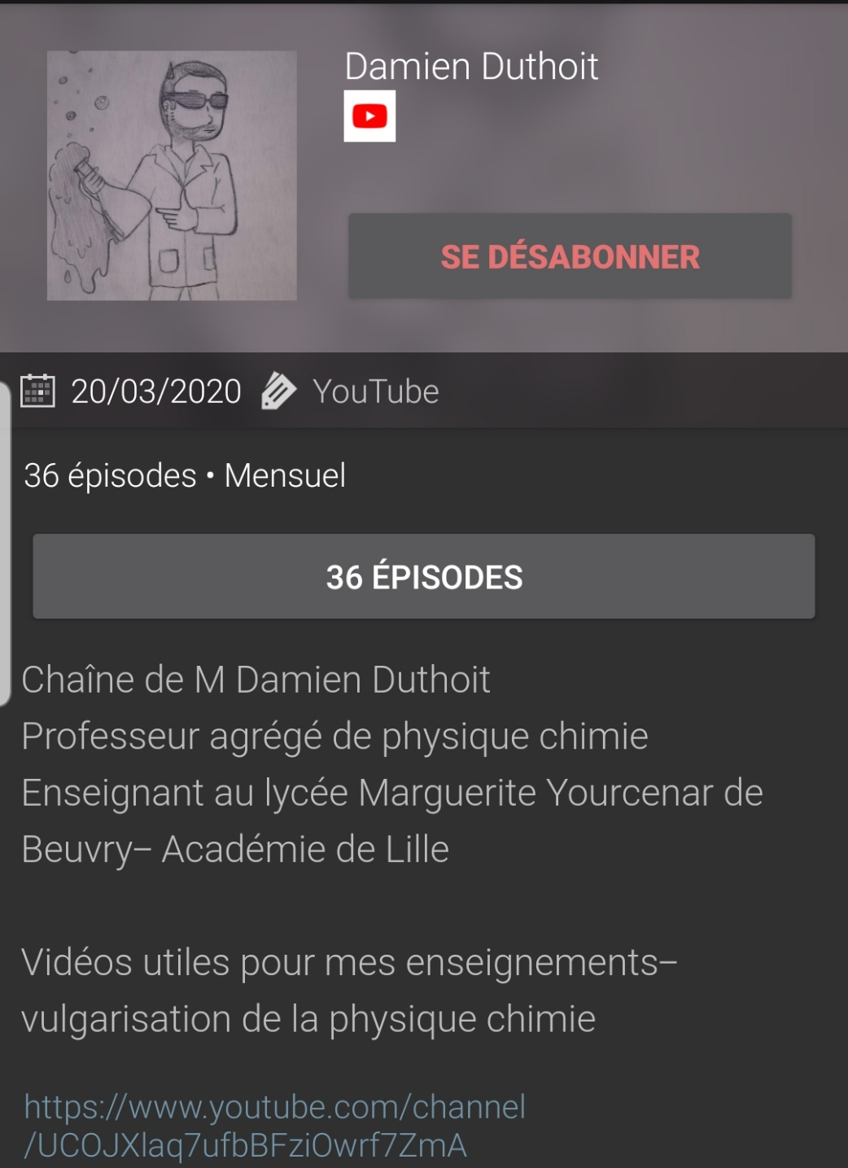
https://www.youtube.com/channel/UCOJXlaq7ufbBFziOwrf7ZmA

