What exactly is British teatime?

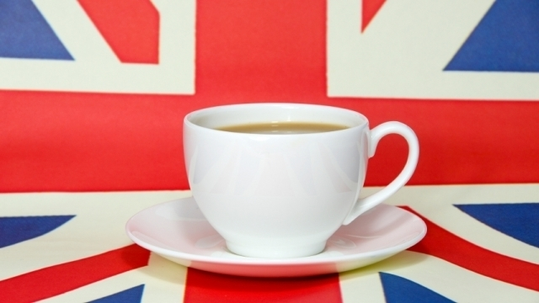

Do the British really get together every afternoon at 4 to sit and drink several cups of tea? Ask any of my German students and they will tell you 'YES!'

I’m sorry to disappoint, but it’s simply not true. We drink over 150 million cups of tea a day in Britain, but there is no special time for the nation’s favourite drink. British people will drink tea all day whether morning, noon or night (my mother makes her first cup at 6 am!). There are reasons for the confusion surrounding ‘teatime’, however ...

‘Tea’ is widely used as a name for the evening meal. This is more common in Scotland and the north of England but you can hear it all over the country. Usually it is the main meal of the day, eaten between 5 and 7. So, ‘teatime’ refers to the meal and not the drink. In the south, the evening meal is often called dinner, while dinner in the north is the midday meal. Confused? Many heated debates can happen between southerners and northerners about the right name, but in general:

North: Breakfast - Dinner - Teatime

South: Breakfast - Lunch - Dinner

What about tea breaks? Surely this must be a special time for tea? Wrong again, I’m afraid. Tea breaks are simply an opportunity to have a rest from work for around 10 minutes. In this time you can drink *whatever* you like (which of course includes tea). This is usually with a small snack, like biscuits for dunking. The best time for a tea break is mid-morning around 11 or mid-afternoon around 3.

But what about tea rooms? Can I drink tea there? *Yes!* A tea room is the perfect place to go with friends and family to enjoy tea, cakes, sandwiches and pastries. This is known as afternoon tea and is usually saved for special occasions such as a birthday or engagement party. In Devon and Cornwall, afternoon tea is served with scones and locally made clotted cream and strawberry jam - we call this a cream tea. While a rare occasion for Brits, tea rooms are very popular with tourists and are definitely worth a visit.

# Afternoon Tea

##### by Ben Johnson

**“There are few hours in life more agreeable than the hour dedicated to the ceremony known as afternoon tea.”**  
Henry James

Afternoon tea, that most quintessential of English customs is, perhaps surprisingly, a relatively new tradition. Whilst the custom of drinking tea dates back to the third millennium BC in China and was popularised in England during the 1660s by King Charles II and his wife the Portuguese Infanta Catherine de Braganza, it was not until the mid 19th century that the concept of ‘afternoon tea’ first appeared.

Afternoon tea was introduced in England by Anna, the seventh Duchess of Bedford, in the year 1840. The Duchess would become hungry around four o’clock in the afternoon. The evening meal in her household was served fashionably late at eight o’clock, thus leaving a long period of time between lunch and dinner. The Duchess asked that a tray of tea, bread and butter (some time earlier, the [Earl of Sandwich](http://www.historic-uk.com/CultureUK/British-Trendsetters/) had had the idea of putting a filling between two slices of bread) and cake be brought to her room during the late afternoon. This became a habit of hers and she began inviting friends to join her.

This pause for tea became a fashionable social event. During the 1880’s upper-class and society women would change into long gowns, gloves and hats for their afternoon tea which was usually served in the drawing room between four and five o’clock.

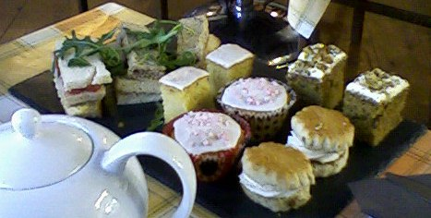

Traditional afternoon tea consists of a selection of dainty sandwiches (including of course thinly sliced cucumber sandwiches), scones served with clotted cream and preserves. Cakes and pastries are also served. Tea grown in India or Ceylon is poured from silver tea pots into delicate bone china cups.

Nowadays however, in the average suburban home, afternoon tea is likely to be just a biscuit or small cake and a mug of tea, usually produced using a teabag. Sacrilege!

To experience the best of the afternoon tea tradition, indulge yourself with a trip to one of London’s finest hotels or visit a quaint tearoom in the west country. The Devonshire Cream Tea is famous world wide and consists of scones, strawberry jam and the vital ingredient, Devon clotted cream, as well as cups of hot sweet tea served in china teacups. Many of the other counties in England’s west country also claim the best cream teas: Dorset, Cornwall and Somerset.

There are a wide selection of hotels in London offering the quintessential afternoon tea experience . Hotels offering traditional afternoon tea include Claridges, the Dorchester, the Ritz and the Savoy, as well as Harrods and Fortnum and Mason.